Customer: | Test customer | Subject: | Test subject
Customer Address: | Placeholder address | From: | Placeholder
Customer Contact: | Placeholder contact | Company: | Maverick Applied Science, Inc.
Inspection Site: | Placeholder site | Maverick Contact Info: | Cell Phone #:89264981267  Email: www@gmail.com
Customer PO No.: | 09435683046739878 | Maverick Job: | 20243121-1
Customer CCs: | Placeholder ccs | Maverick CCs: | D. Mikulec; MAS Technical Director
Inspection Date(s): | 9/17/2024 | Report Date: | 9/18/2024
Introduction: | Example intro
Entrance Meeting: | Example entrance
Drawings provided and used during the inspection:
Test 1
Test 2
Test 3
Test 4
Specifications used during the inspection:
Test 1
Test 2
Test 3
Conclusions and Recommendations: | Example conclusion

Description | Caption | Picture
shows | General View of Chimney Liner | 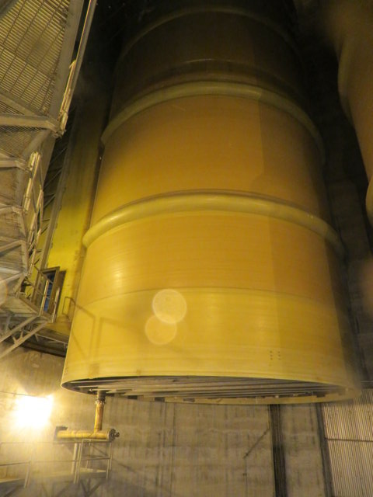
shows | View of Floor Beam Attachment Bolts | 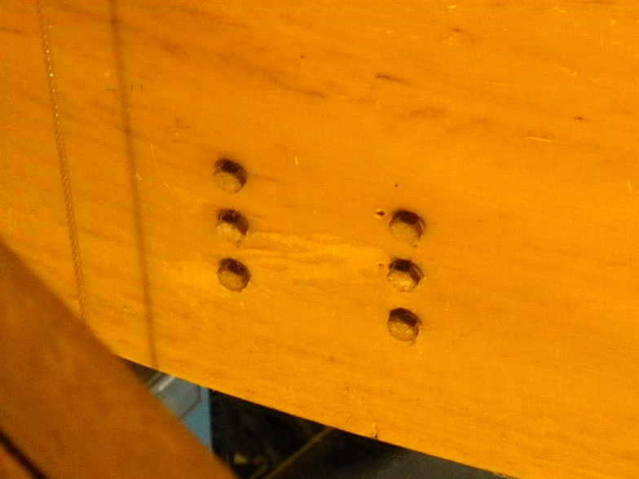
shows | View of Chimney Liner Floor | 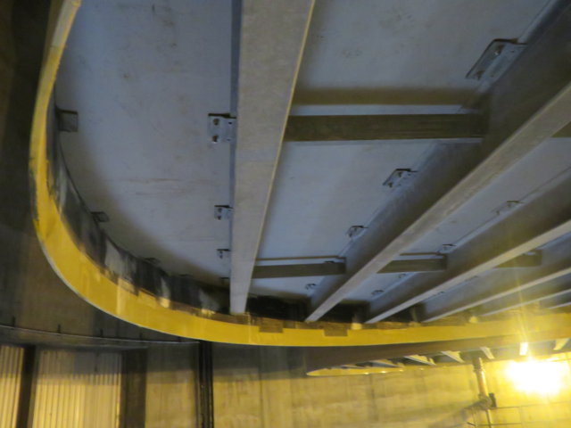
shows | View of Chimney Liner Floor with Repair | 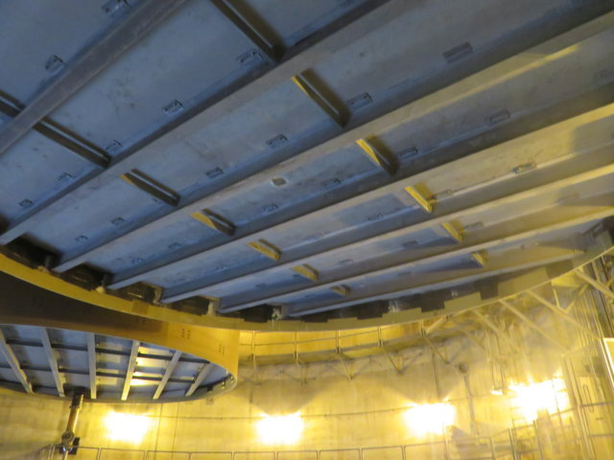
shows | Up-close View of Chimney Liner Floor Repair | 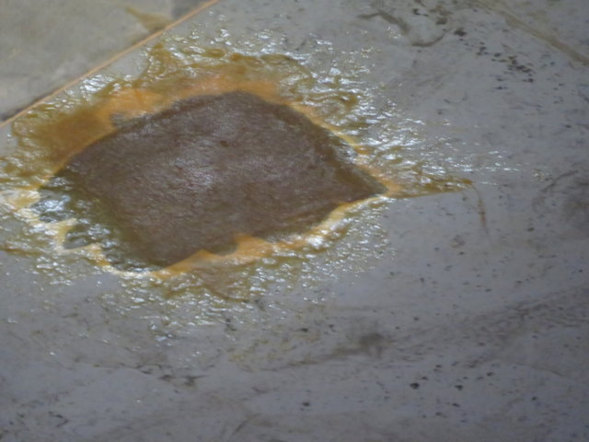
shows | Close-up Internal View of Floor Repair | 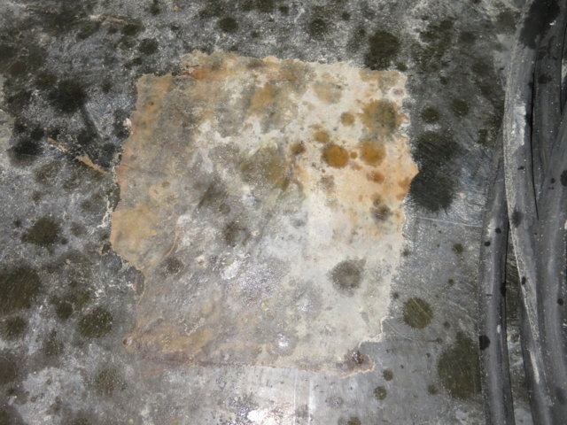
shows | View of Breach to Shell Overlay | 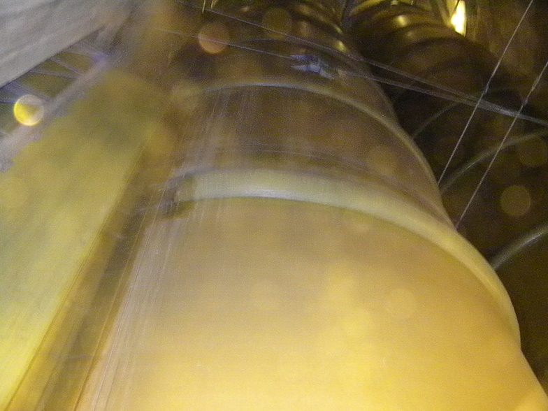
shows | View of Breach to Shell Overlay | 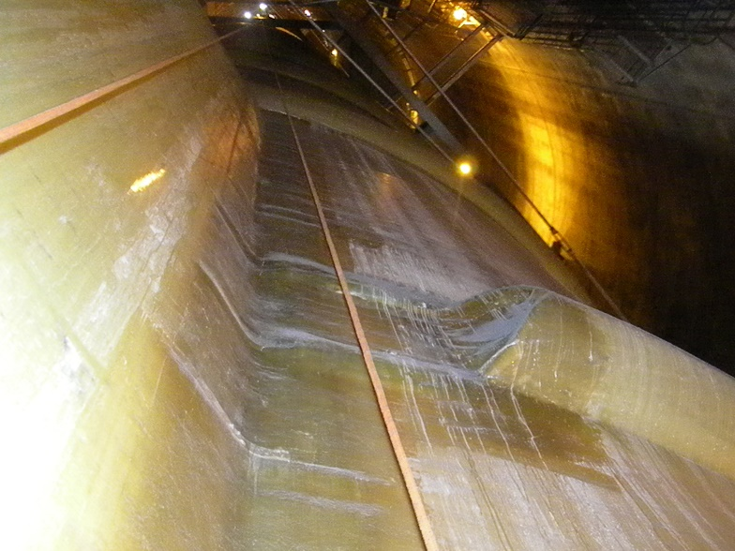
shows | View of Entrapped Air in Breach to Shell Overlay | 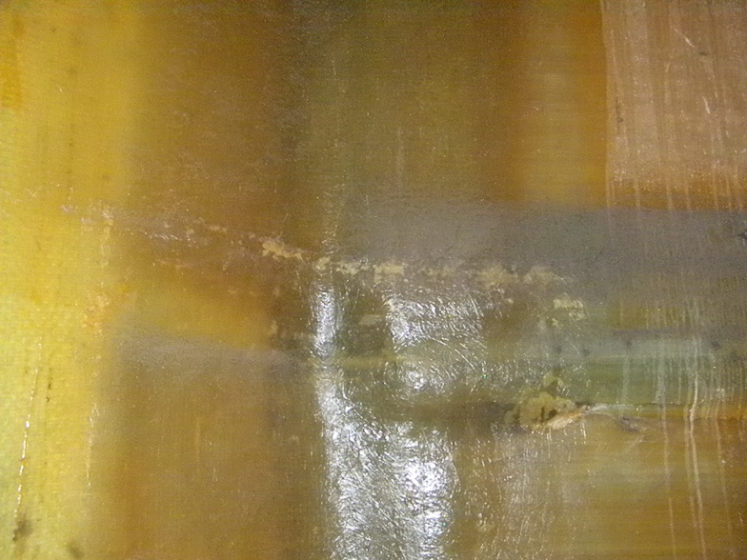
shows | View of Contaminated Glass in Breach to Shell Overlay | 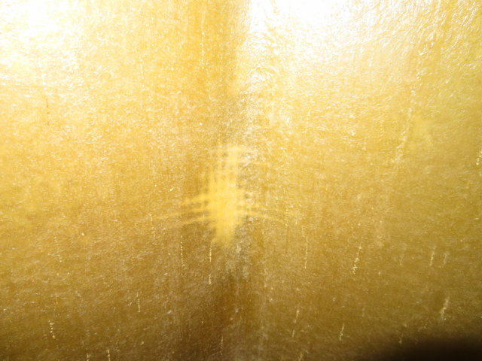
shows | View of Contaminated Glass in Breach to Shell Overlay | 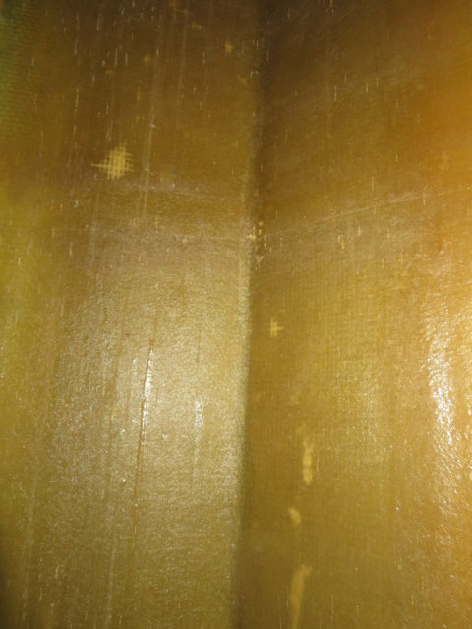
shows | View of Contaminated Glass in Breach to Shell Overlay | 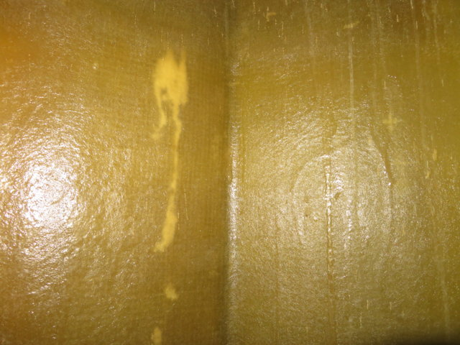
shows | External View of Lower Corner | 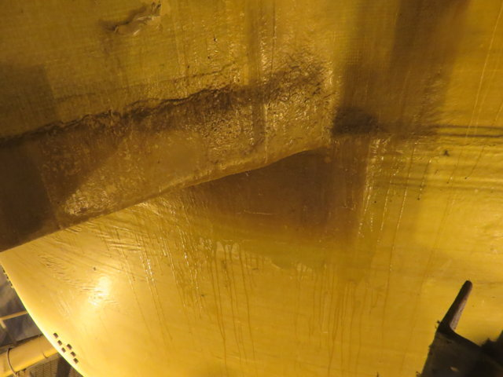
shows | External View of Lower Corner | 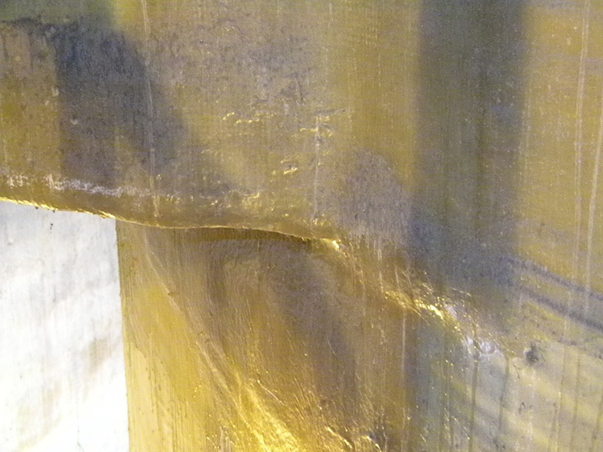
shows | External View of Lower Corner | 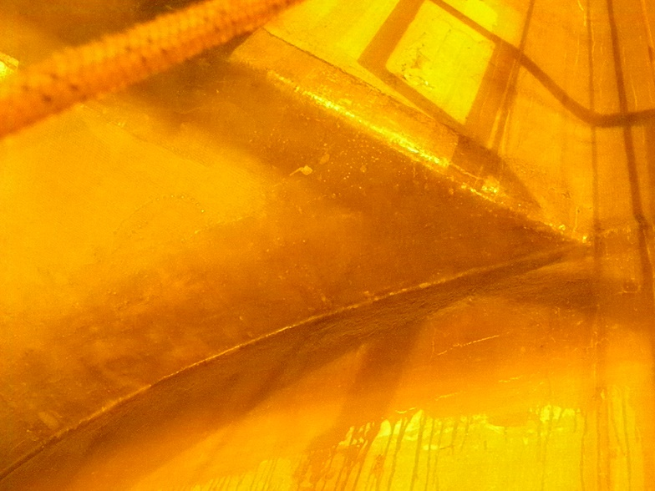
shows | External View of Lower Breach to Shell Joint | 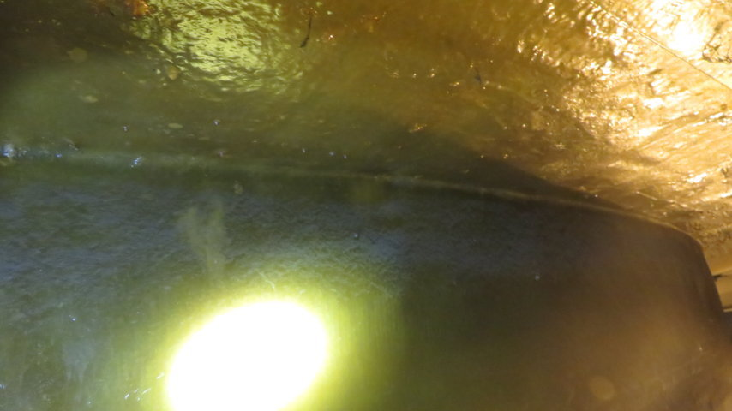
shows | External View of Lower Corner | 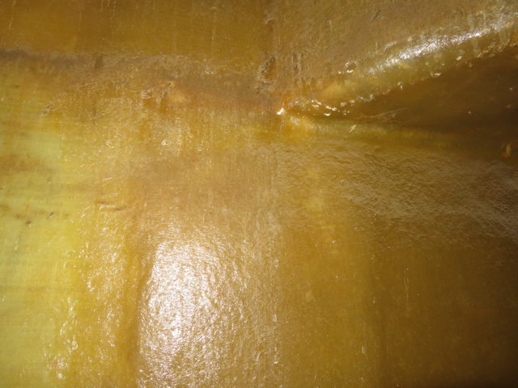
shows | External View of Lower Corner | 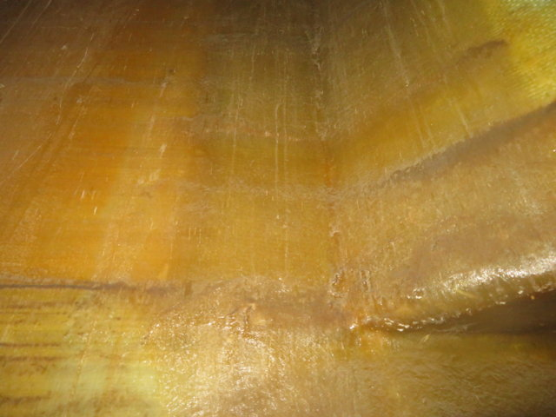
shows | External View of Upper Corner | 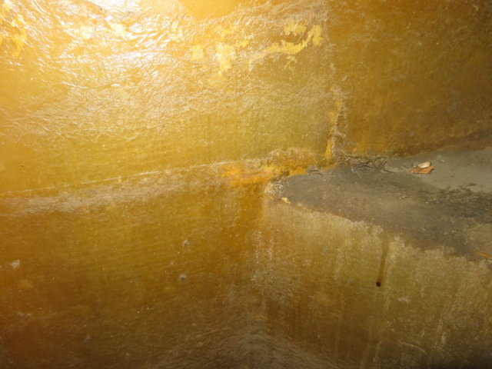
shows | External View of Upper Corner | 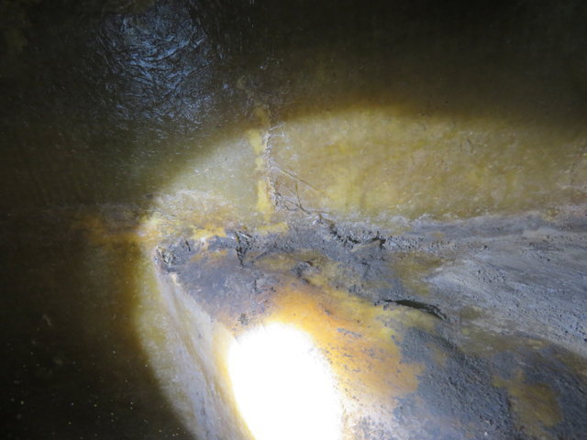
shows | External View of Upper Breach to Shell Overlay | 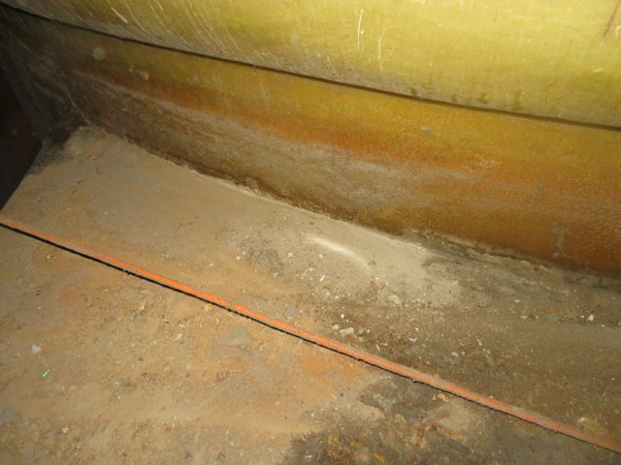
shows | External View of Upper Breach to Shell Overlay | 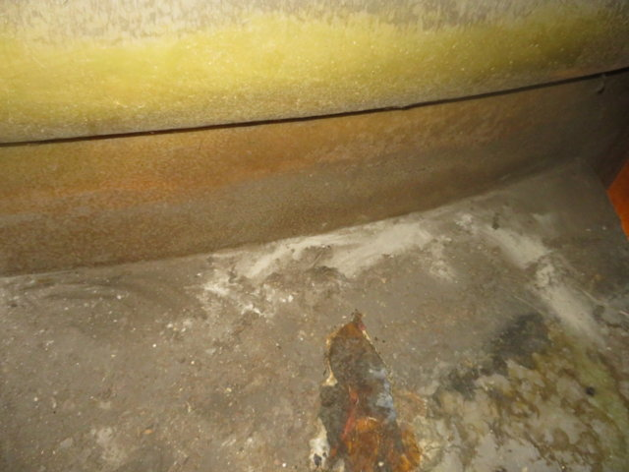
shows | External View of Upper Corner | 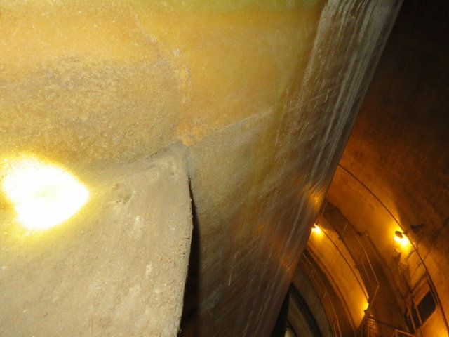
shows | External View of Upper Corner | 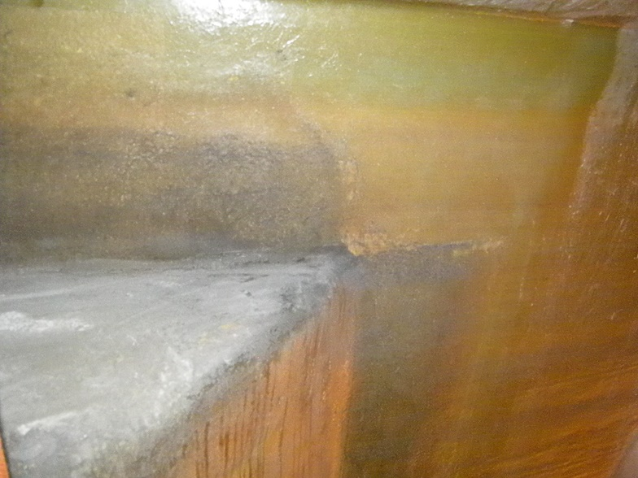
shows | External View of Grounding Lug with Evidence of Leaking | 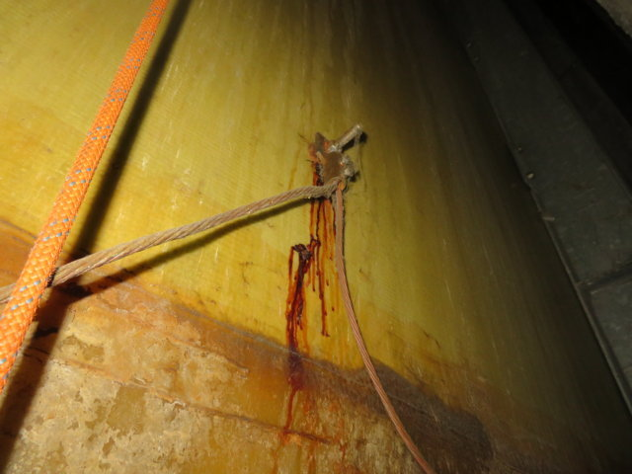
shows | Internal View of Grounding Lug with Evidence of Leaking | 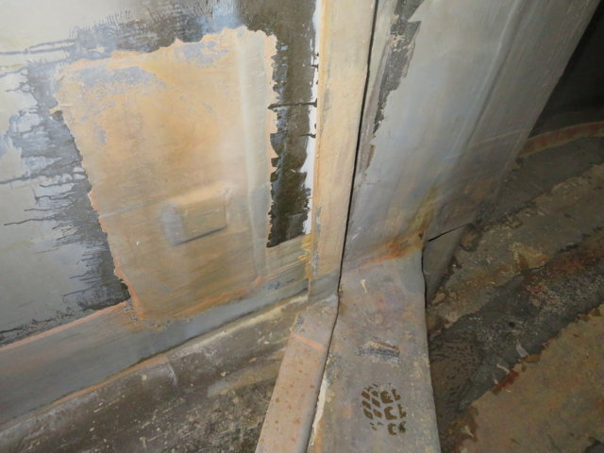
shows | View of Rib Stiffener | 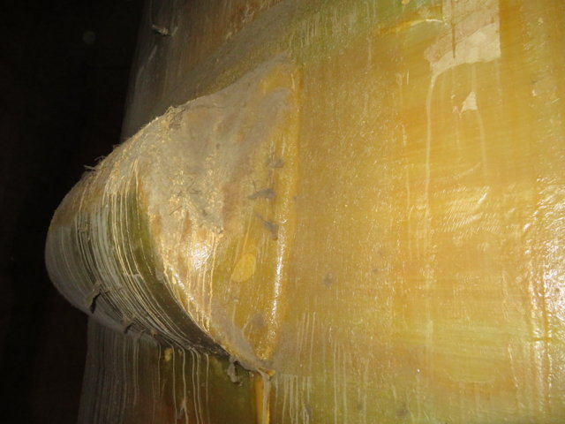
shows | View of Defect in Rib Stiffener | 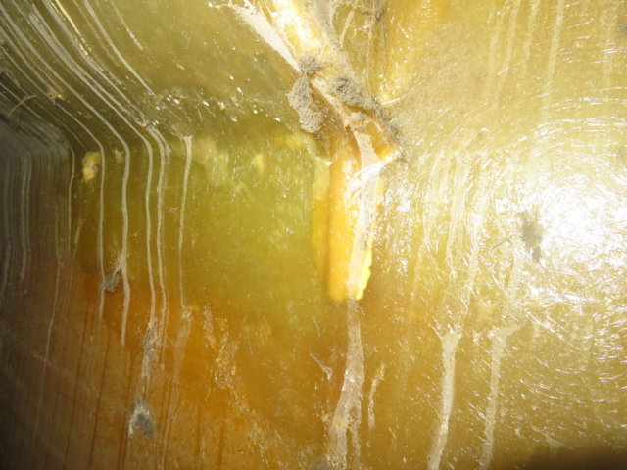
shows | View of Rib Stiffener Defect | 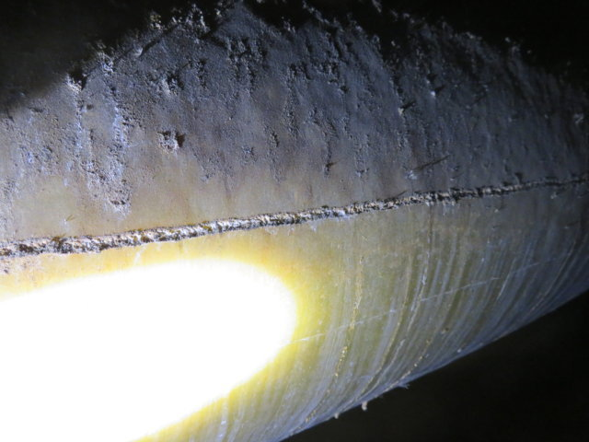
shows | View of Rib Stiffener Defect | 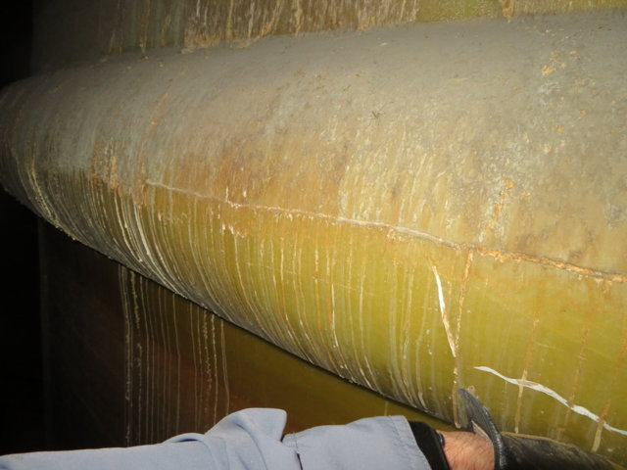
shows | View of Rib Stiffener Defect | 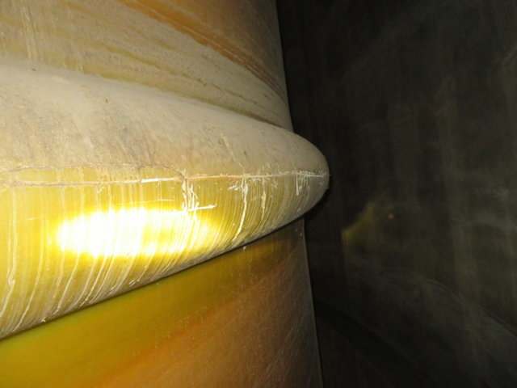
shows | View of Rib Stiffener Defect | 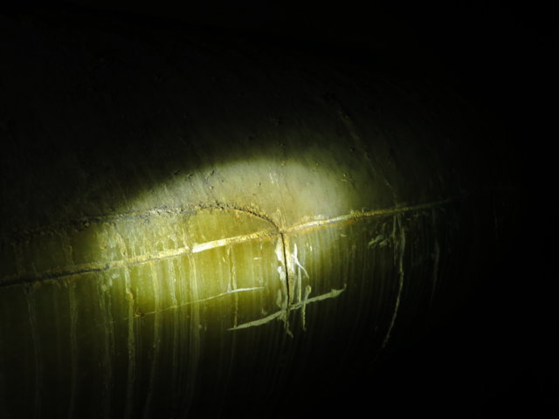
shows | View of Coped Rib Stiffener and Corrosion | 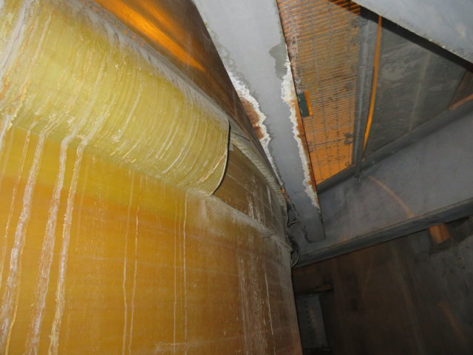
shows | View of Coped Rib Stiffener and Corrosion | 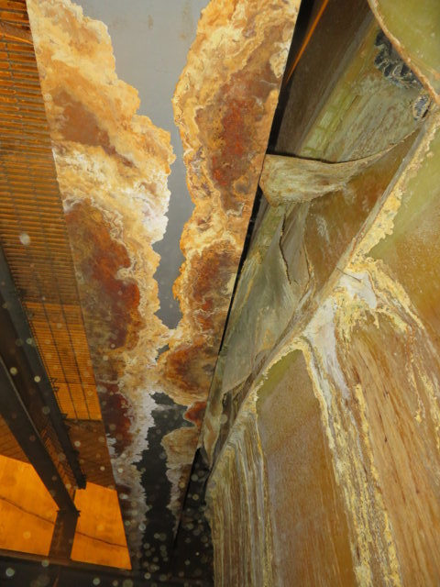
shows | View of Coped Rib Stiffener and Corrosion | 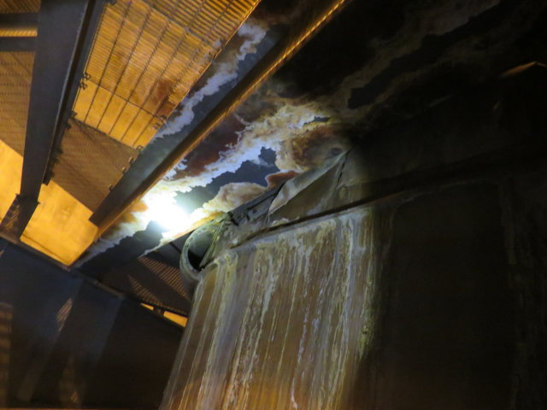
shows | View of Coped Rib Stiffener and Corrosion | 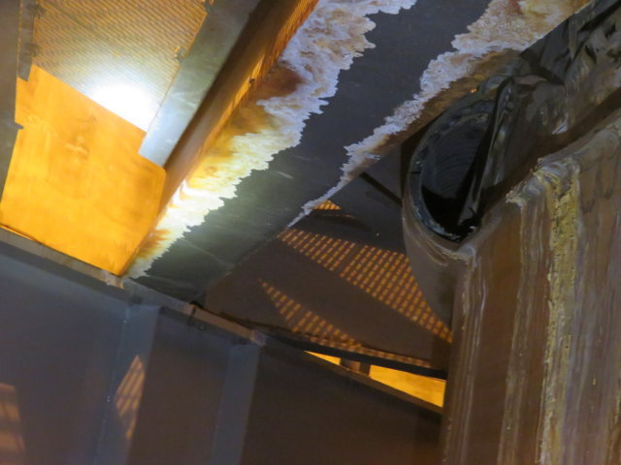
shows | View of Chimney Liner Support and Expansion Joint | 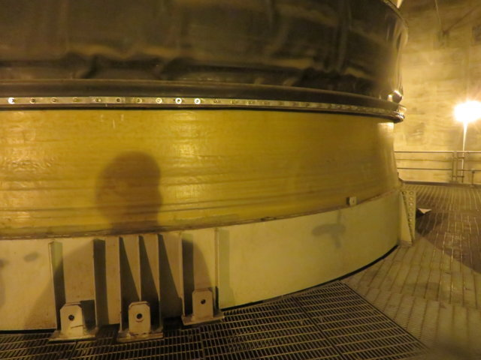
shows | View of Chimney Liner Support and Expansion Joint | 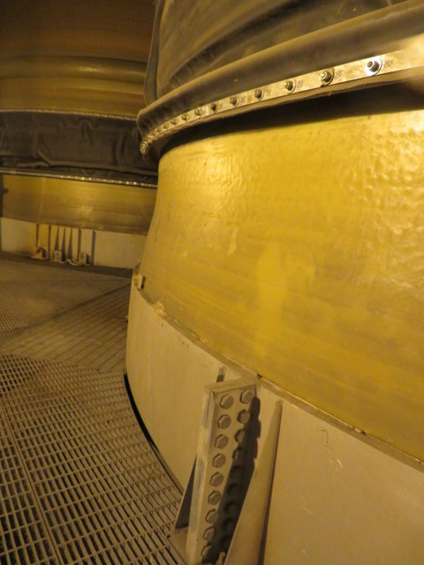
shows | Evidence of Leaking at Expansion Joint Flange | 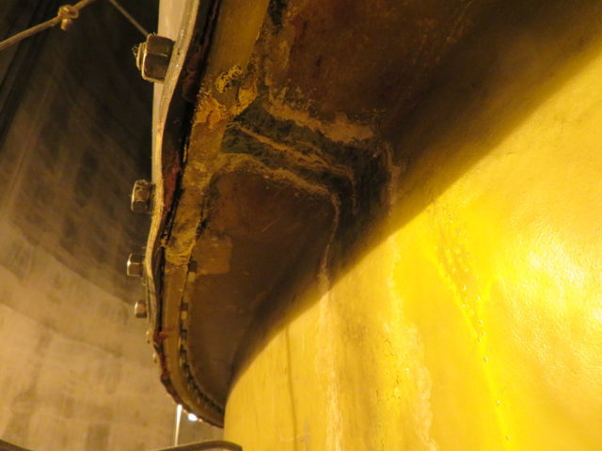
shows | Evidence of Leaking Onto Chimney Liner Support | 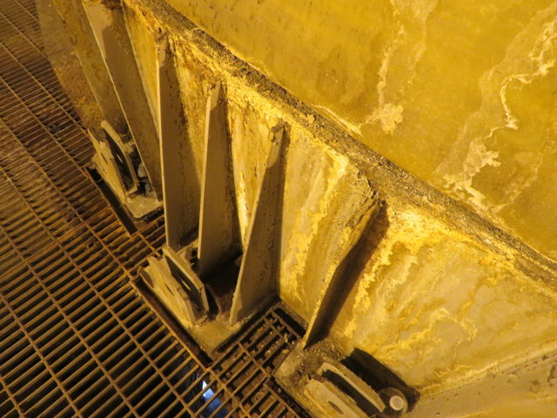
shows | General View of Shell and Rib Defects | 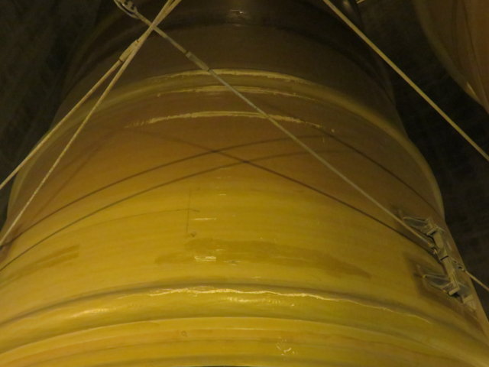
shows | General View of Shell and Rib Defects | 
shows | Close-up View of Shell Defects | 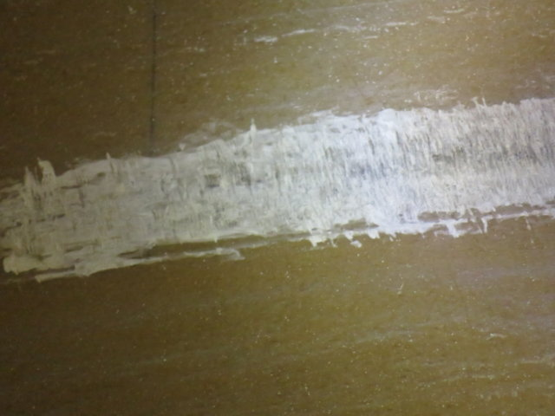
shows | Close-up View of Shell Defects | 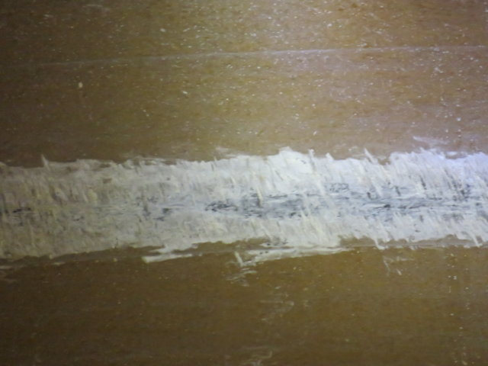
shows | View of Shell and Rib Defects | 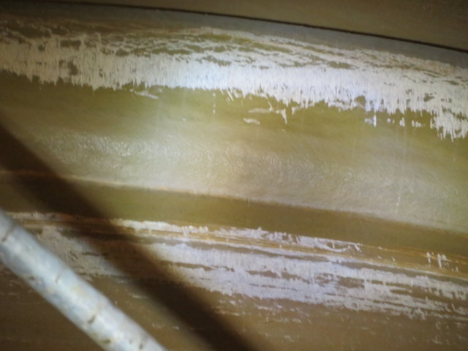
shows | View of Shell and Rib Defects | 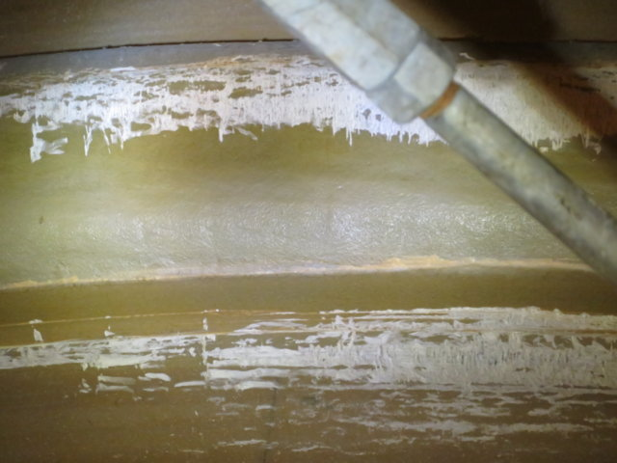
shows | General View of Shell and Rib Defects | 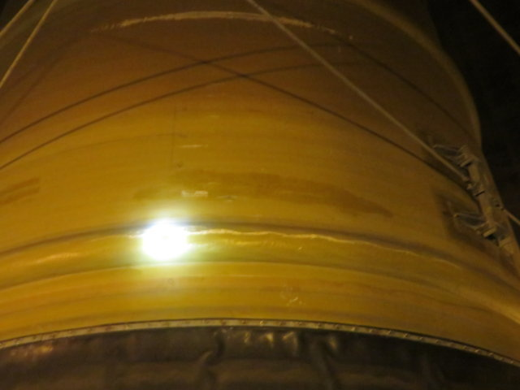
shows | Close-up View of Rib Defect | 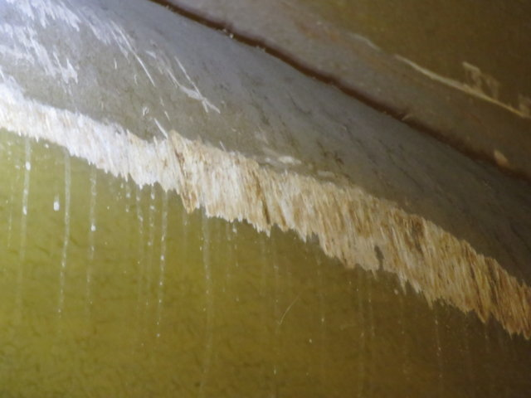
shows | Close-up View of Shell Defect | 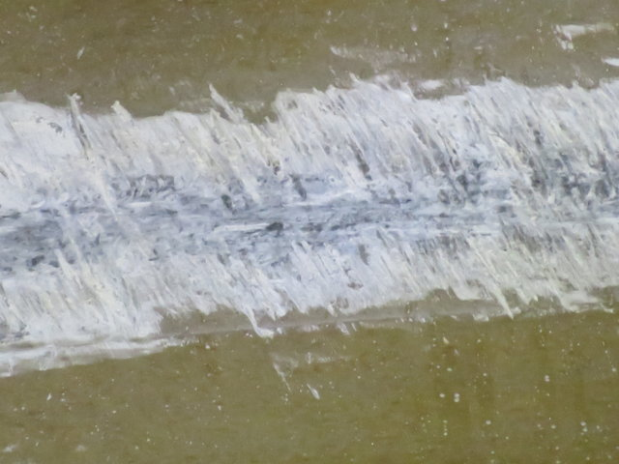
shows | Close-up View of Rib Defect | 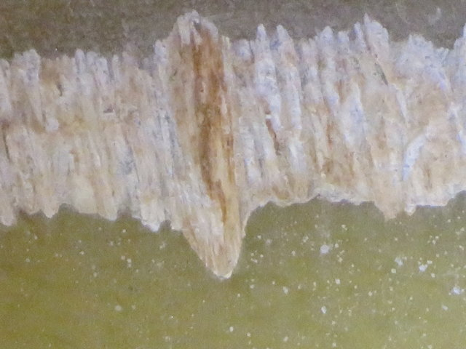
shows | General View of Chimney Liner | 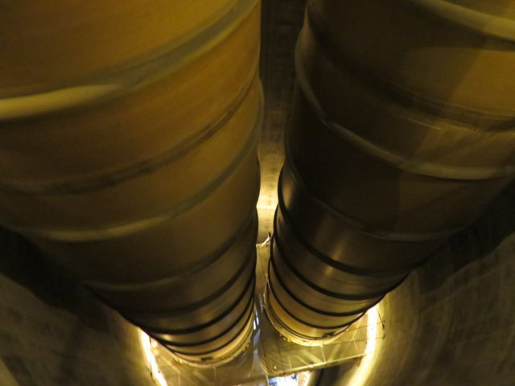
shows | General View of Chimney Liner | 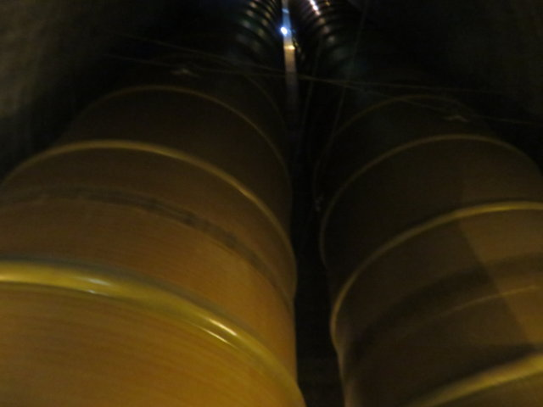
shows | General View of Chimney Liner with Evidence of Leaking | 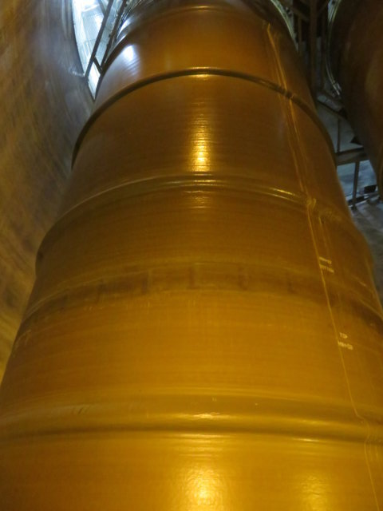
shows | General View of Chimney Liner with Evidence of Leaking | 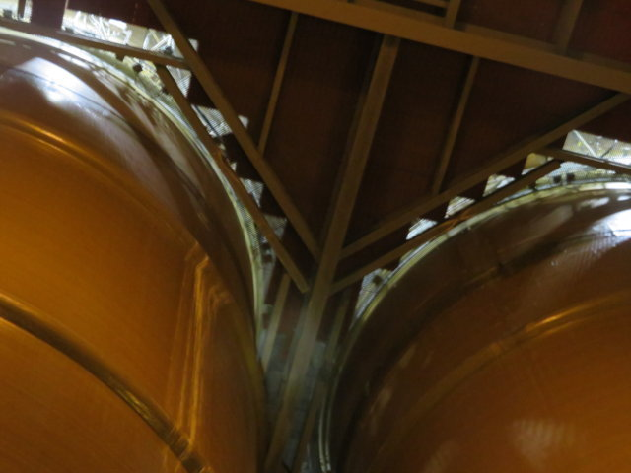
shows | View of Chimney Liner Assembly Joint Edge Peeling | 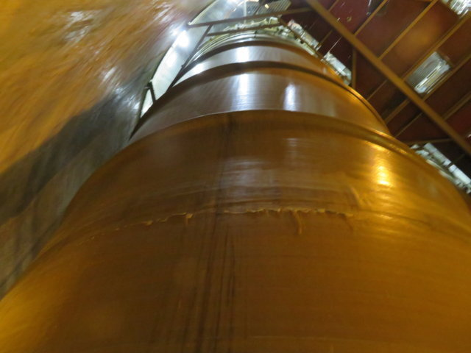
shows | Close-up View of Chimney Liner Assembly Joint Edge Peeling | 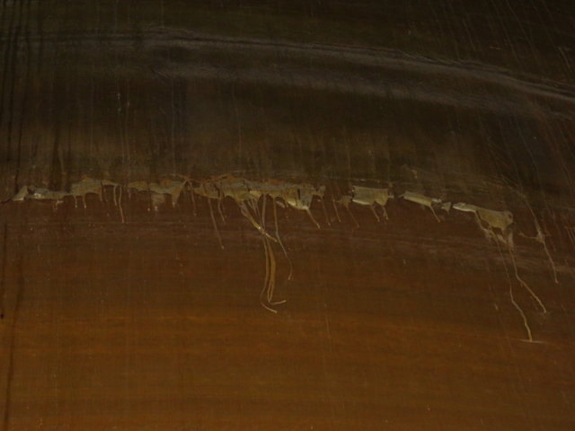
shows | General View of Chimney Liner Assembly Joint Defect | 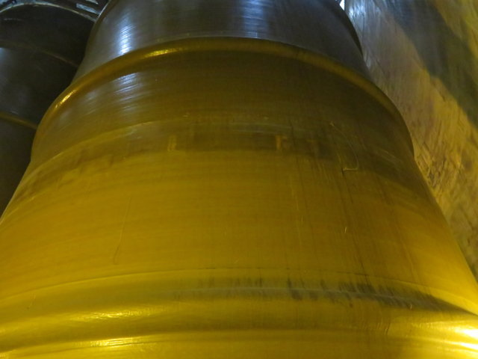
shows | Close-up View of Chimney Liner Assembly Joint Defect | 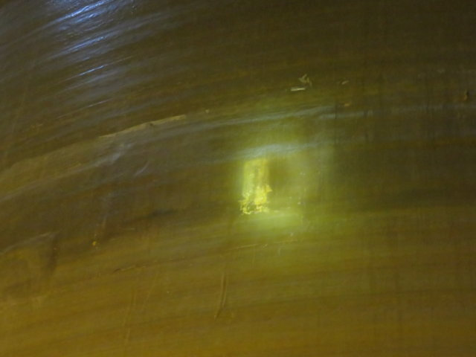
shows | View of Flanges Missing Bolts | 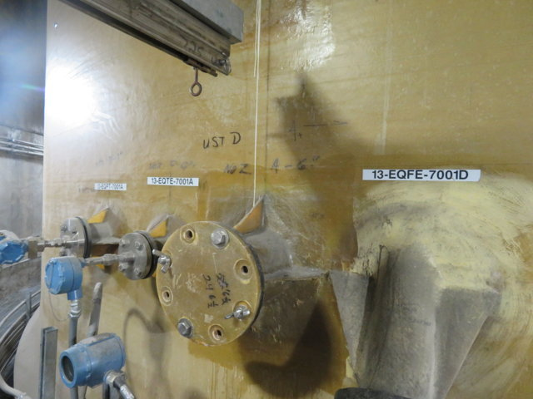
shows | View of Flanges Missing Bolts | 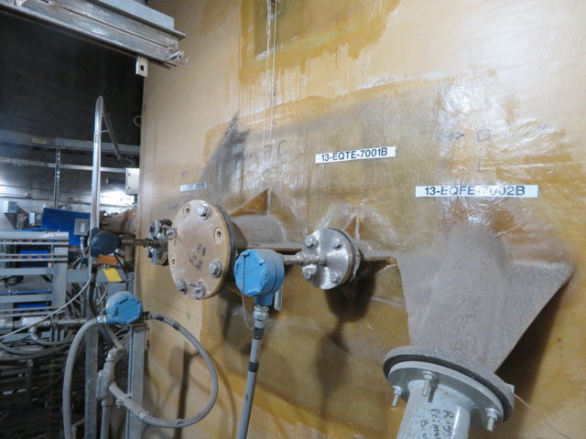
shows | View of Flanges Missing Bolts | 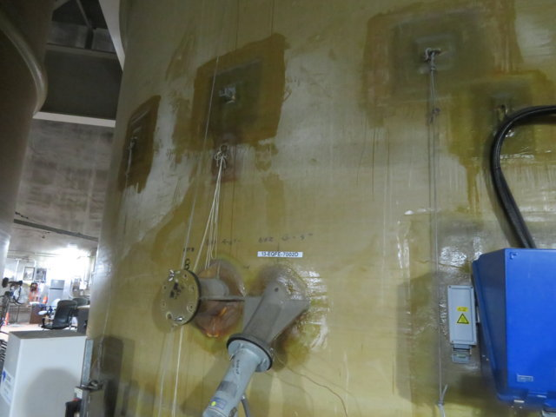
shows | View of Nozzle Gusset Overlay Delaminations | 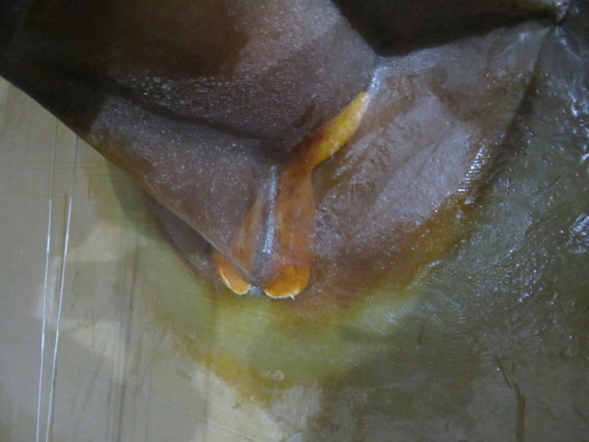
shows | Evidence of Leaking | 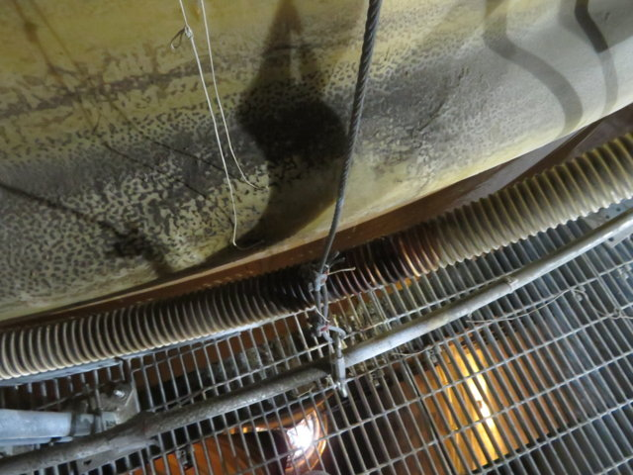
shows | Close-up View of Leaking and Corrosion | 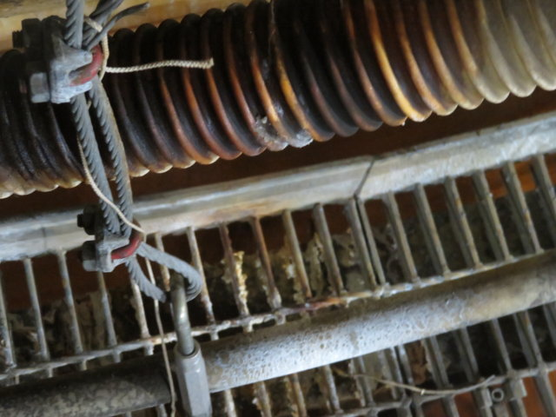
shows | View of Flanges Without Bolts | 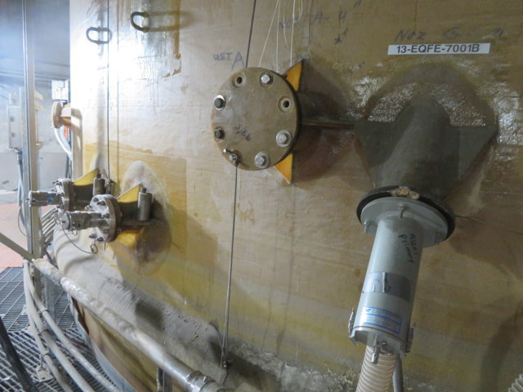
shows | View of Fractured Flange Face | 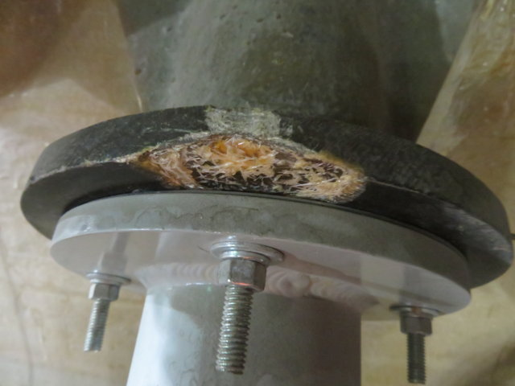
shows | General View of Support Lugs | 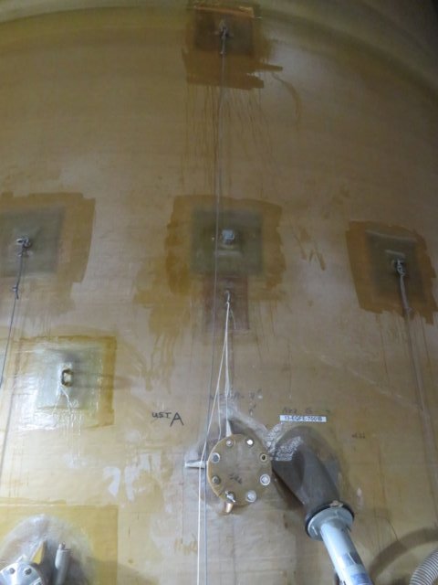
shows | Close-up View of Support Lug Overlay Delamination | 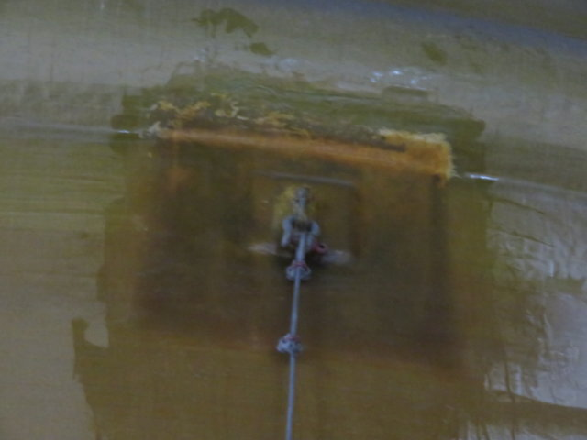
shows | General View of Upper Chimney Liner Support and Nozzles | 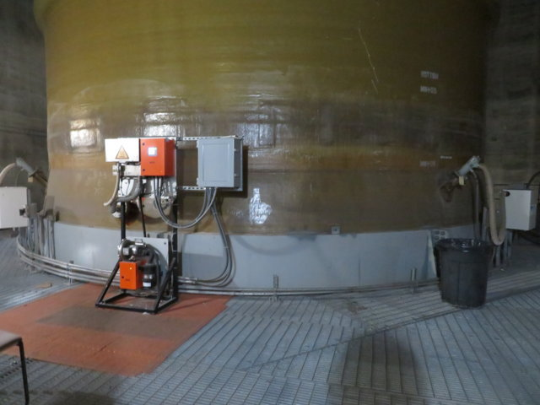
shows | View of Upper Chimney Liner Support | 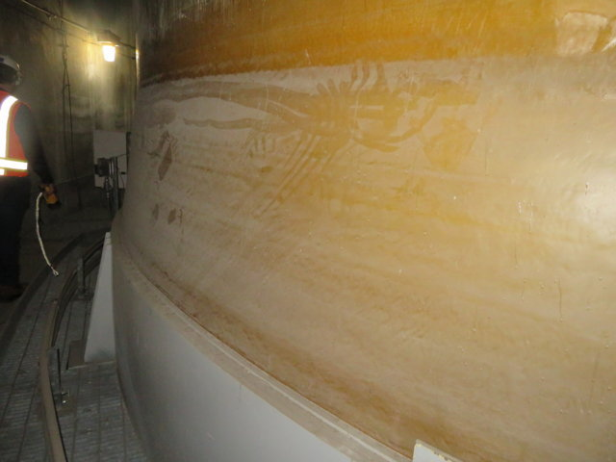
shows | View of Defects in Unit 46 Chimney Liner Assembly Joint | 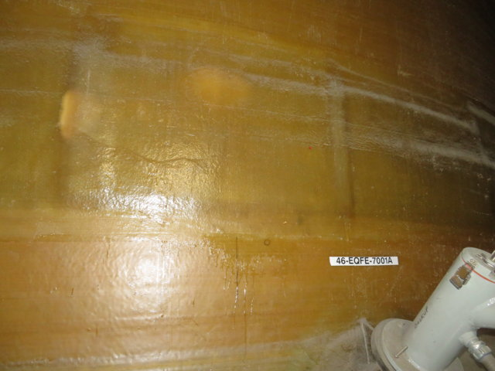
shows | View of Defects in Unit 46 Chimney Liner Assembly Joint | 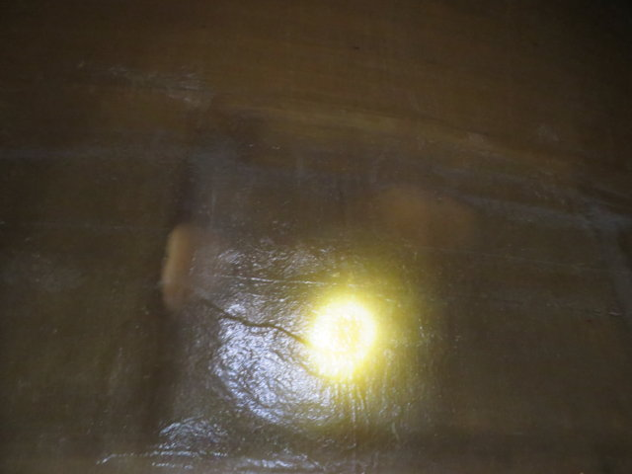
shows | General View of Upper Shell | 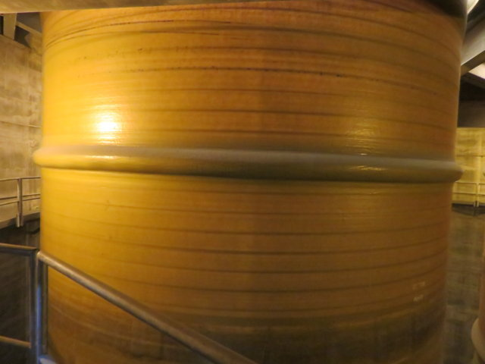
shows | View of Upper Shell Bumpers | 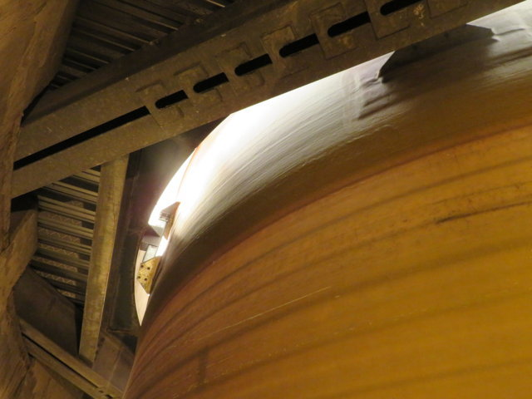
shows | View of Shell and Lightning Arrest System | 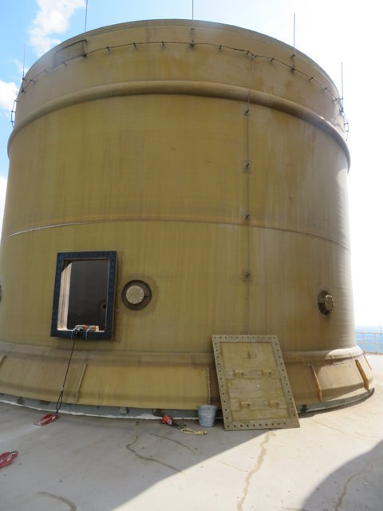
shows | View of Lightning Arrest System | 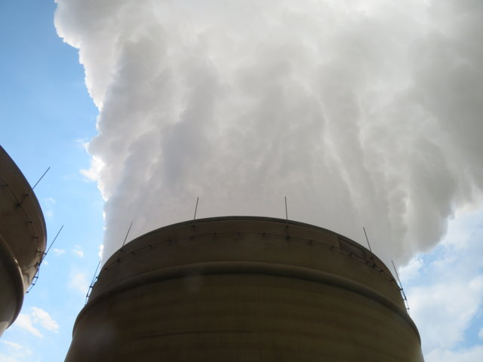
shows | View of Fiber Bloom | 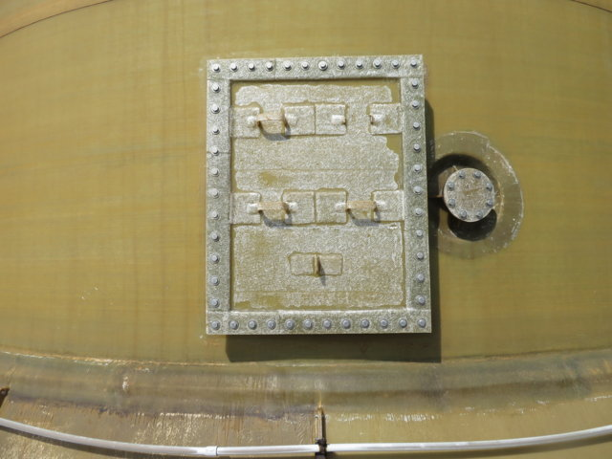
shows | View of Fiber Bloom | 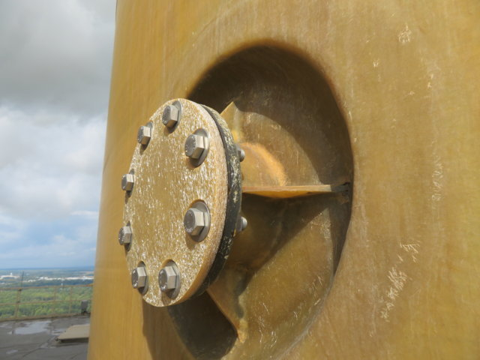
shows | General View Looking Down Chimney Liner | 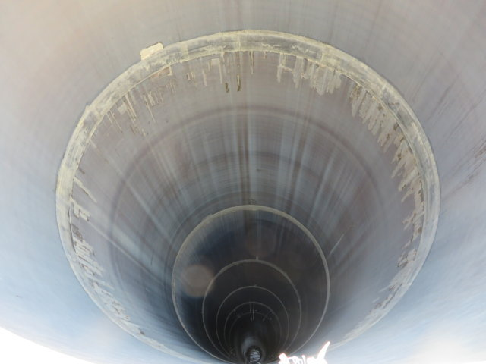
shows | Internal View of Upper Shell | 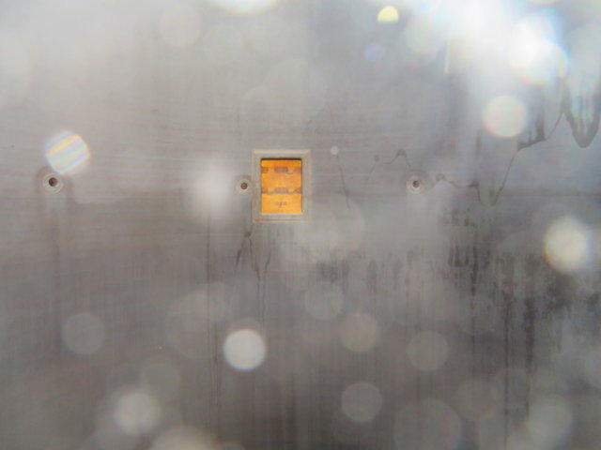
shows | Internal View of Breach Manway Opening | 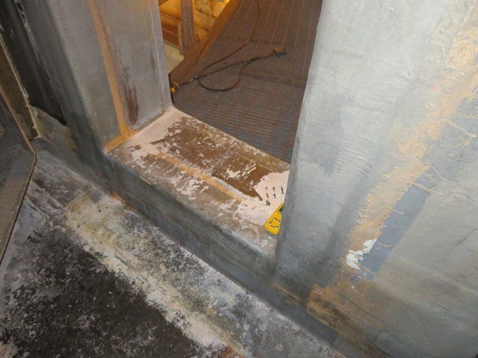
shows | Internal View of Breach Manway Opening | 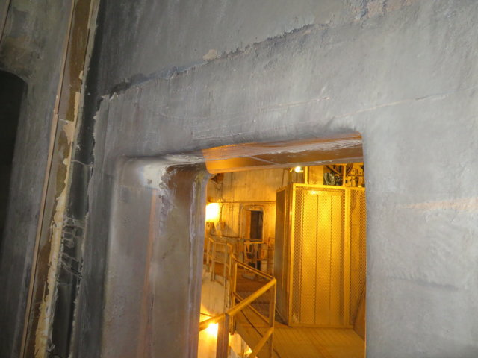
shows | General View of Internal Floor | 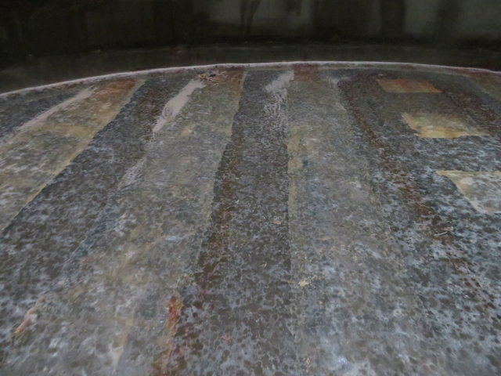
shows | General View of Internal Floor | 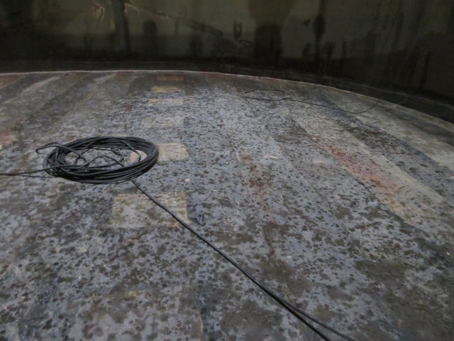
shows | View of Internal Floor Drain | 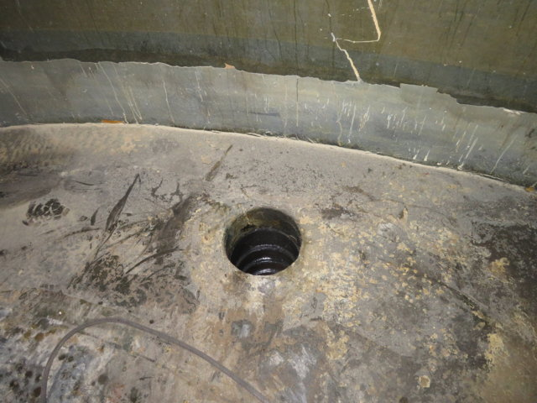
shows | Close-up View of Internal Floor Drain | 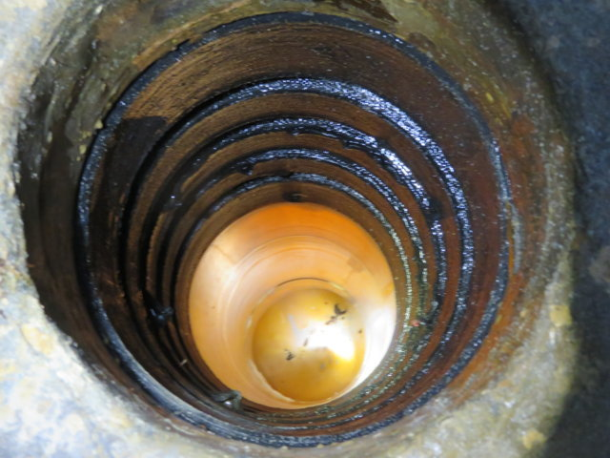
shows | View of Chimney Liner Floor to Shell Overlay with Defects | 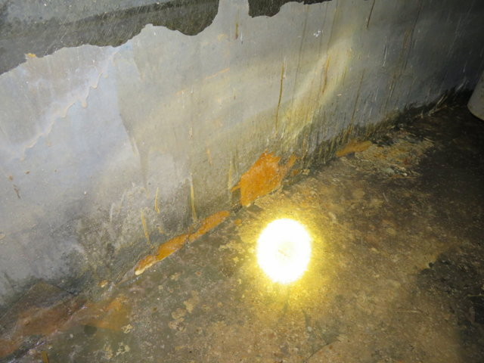
shows | View of Chimney Liner Floor to Shell Overlay with Defects | 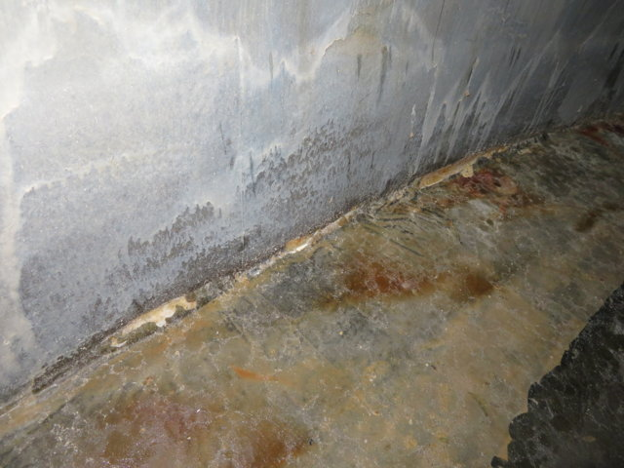
shows | View of Chimney Liner Floor to Shell Overlay with Defects | 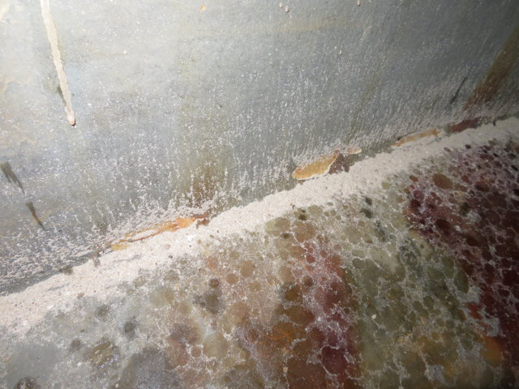
shows | View of Chimney Liner Floor to Shell Overlay with Defects | 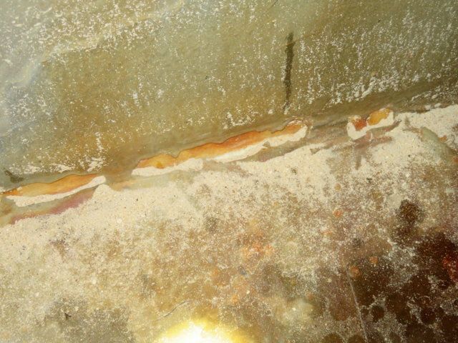
shows | Internal View of Lower Corner | 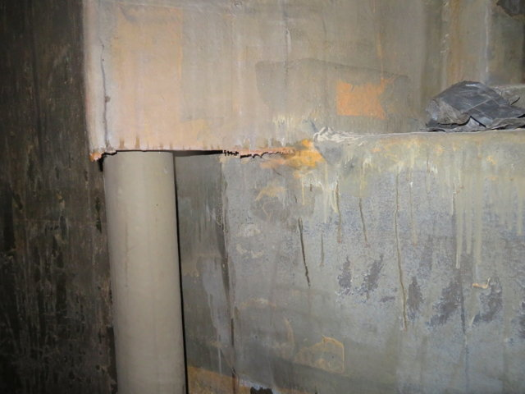
shows | Internal View of Lower Corner | 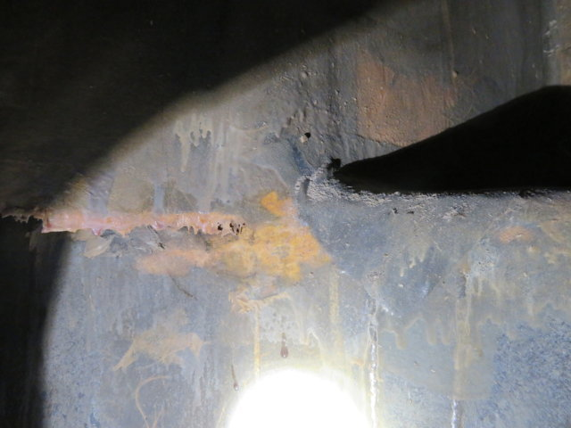
shows | Internal View of Lower Breach to Shell Overlay | 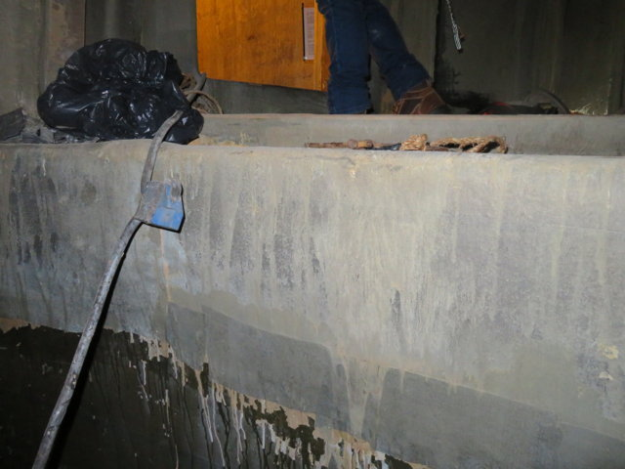
shows | Internal View of Lower Breach to Shell Overlay | 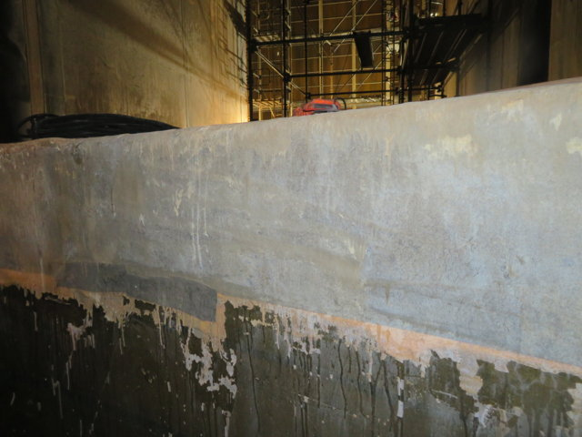
shows | Internal View of Lower Corner | 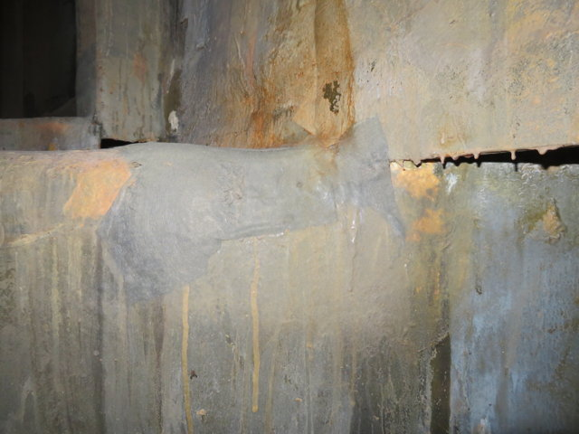
shows | Internal View of Lower Corner | 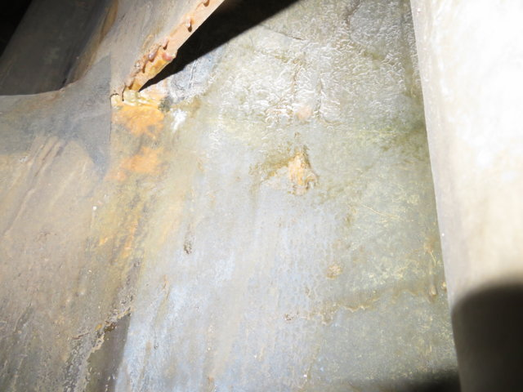
shows | Internal View of Upper Corner | 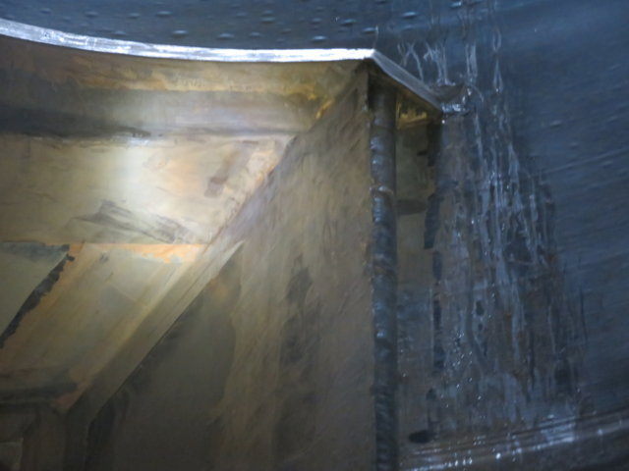
shows | Internal View of Upper Corner | 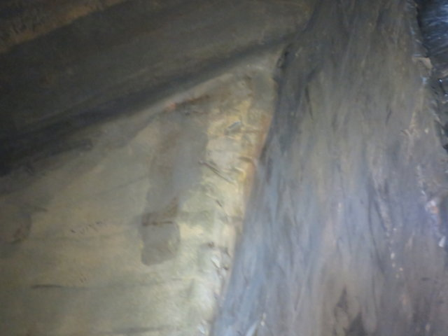
shows | Internal View of Upper Breach to Shell Overlay | 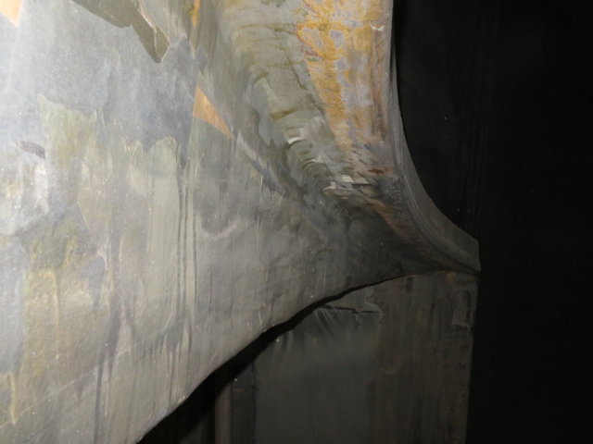
shows | Internal View of Upper Breach to Shell Overlay | 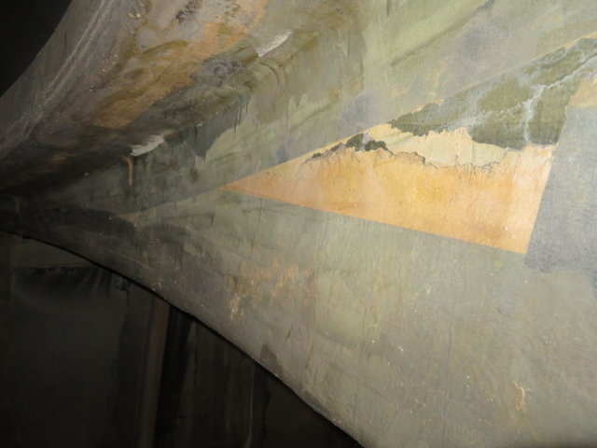
shows | Internal View of Upper Corner | 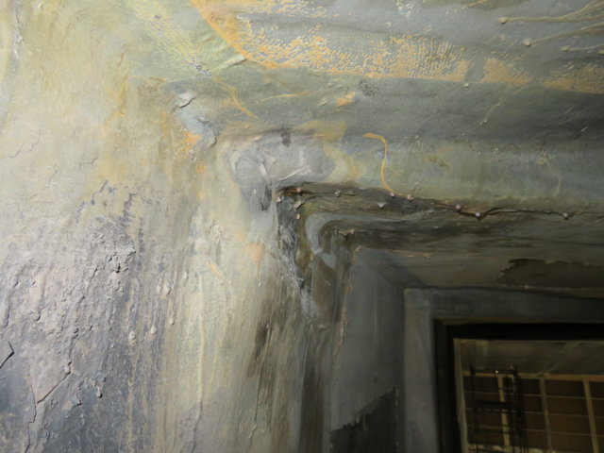
shows | Internal View of Upper Corner | 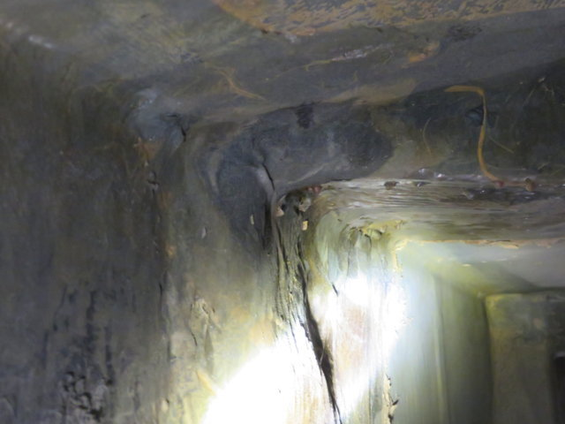
shows | Internal View of Upper Breach Liquid Collection Gutter | 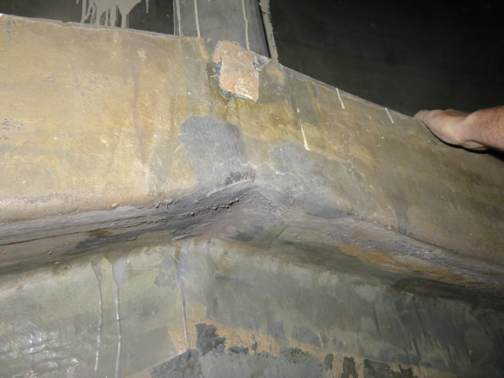
shows | View of Missing Gussets in Liquid Collection Gutter | 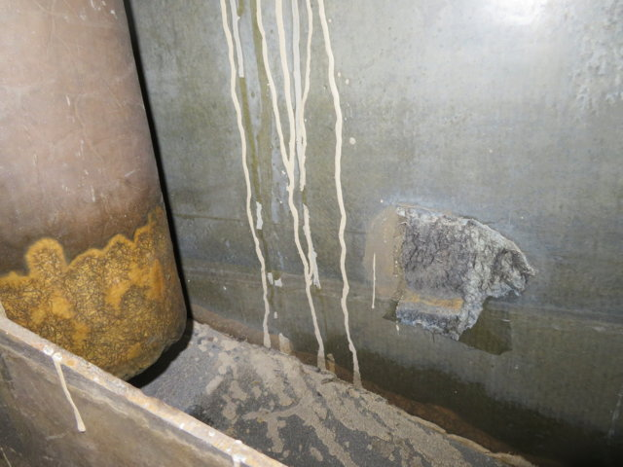
shows | View of Missing Gussets in Liquid Collection Gutter | 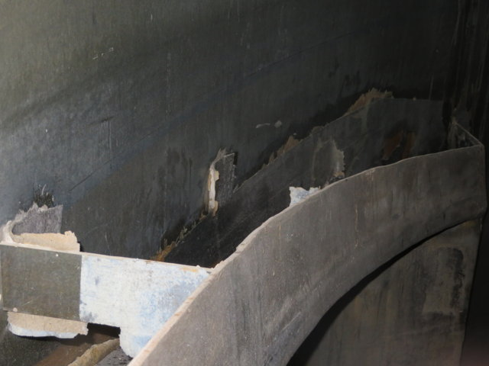
shows | View of Liquid Collection Gutter | 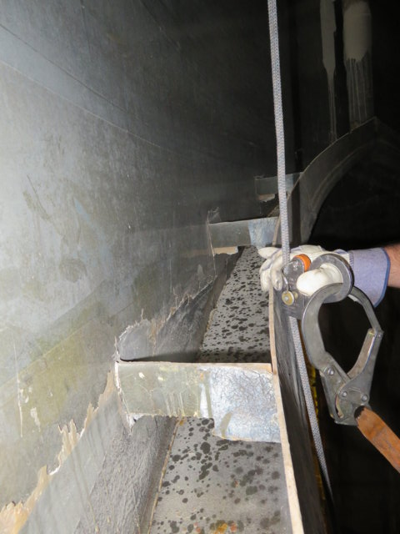
shows | View of Blistering in Shell Corrosion Barrier | 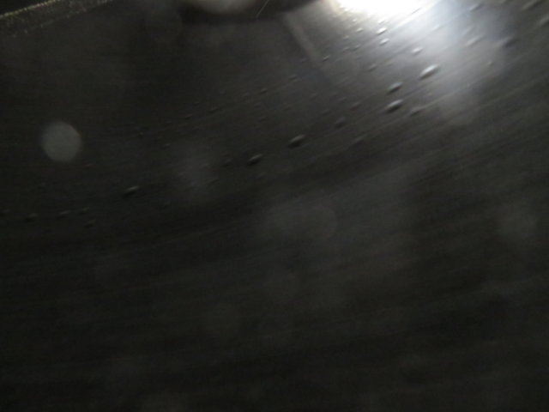
shows | View of Blistering in Shell Corrosion Barrier | 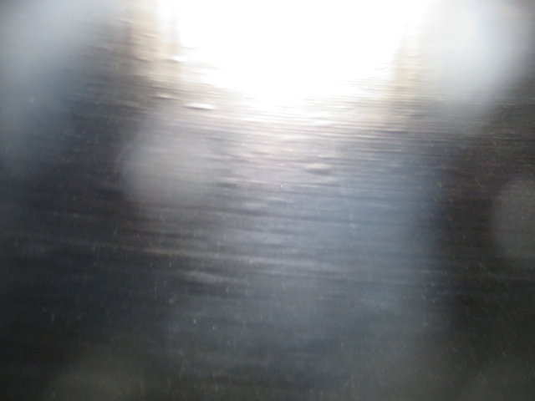
shows | View of Internal Liquid Collection System Drain Pipe | 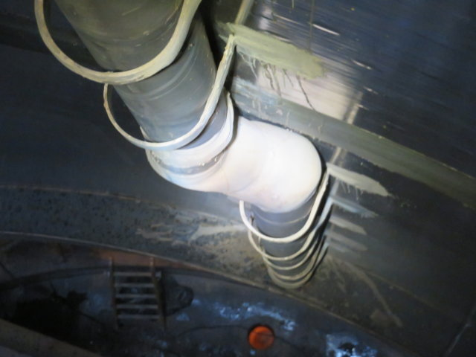
shows | View of Internal Liquid Collection System Drain Pipe | 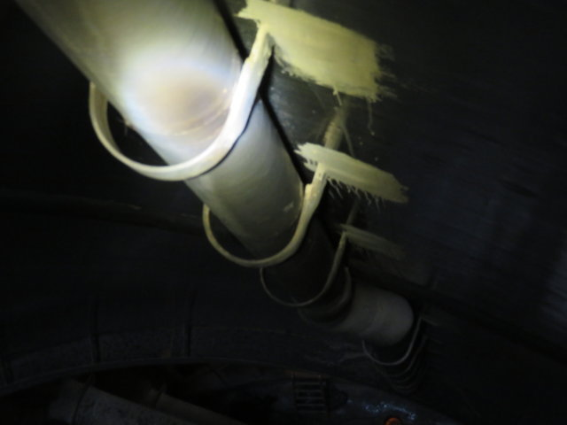
shows | View of Missing Support from Internal Liquid Collection System Drain Pipe | 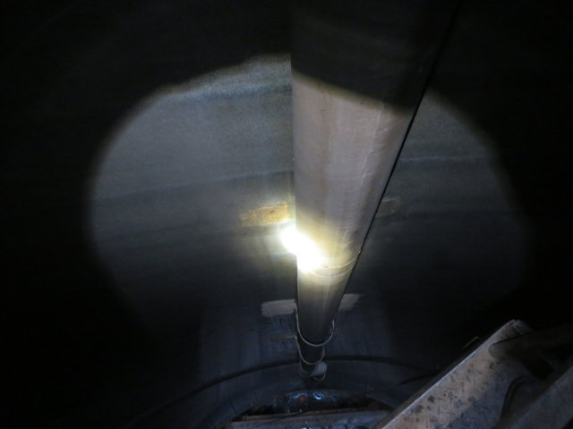
shows | View of Missing Support from Internal Liquid Collection System Drain Pipe | 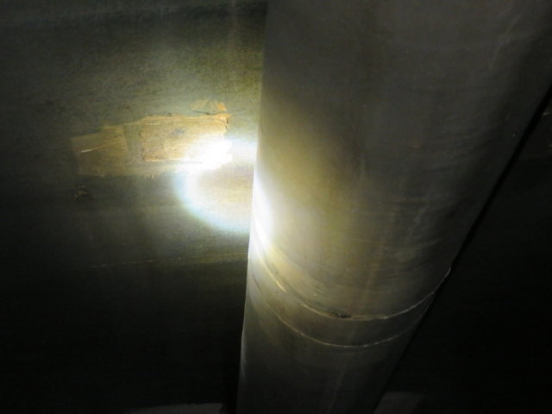
shows | Underside View of Liquid Collection Gutter | 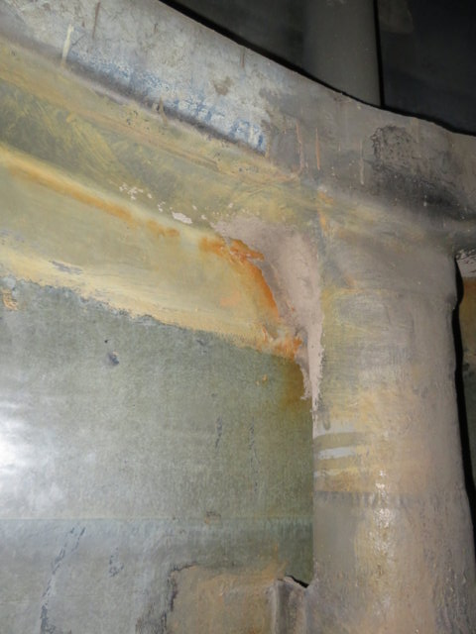
shows | View of Liquid Collection Gutter | 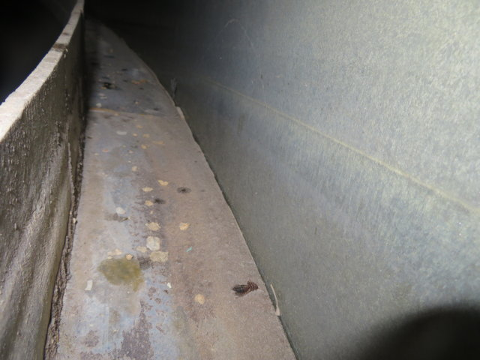
shows | View of Liquid Collection Gutter and Drain Pipes | 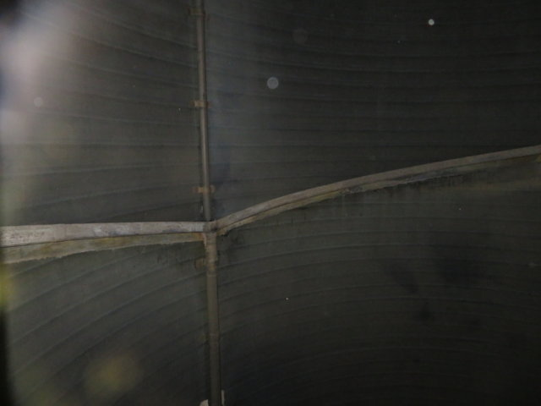
shows | View of Liquid Collection Gutter | 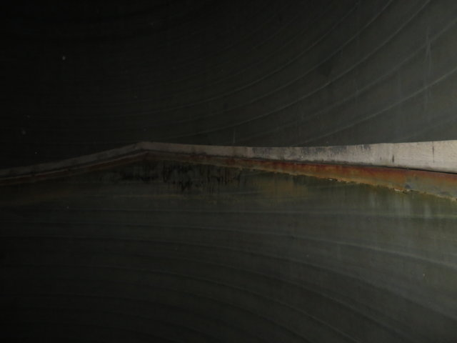
shows | View of Internal Liquid Collection System Drain Pipe | 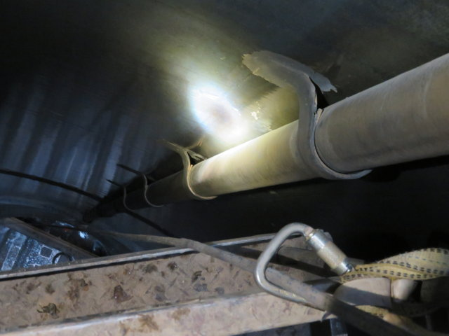
shows | View of Internal Liquid Collection System Drain Pipe | 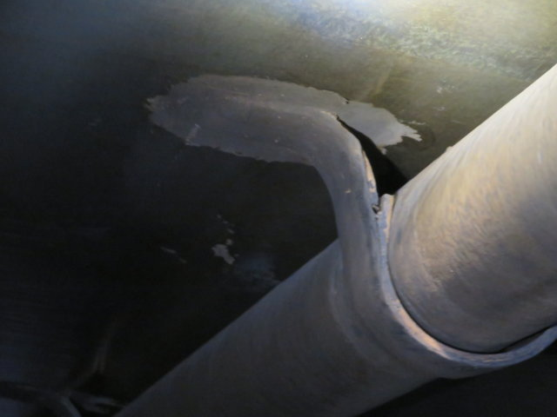
shows | Underside View of Liquid Collection Gutter Underside View of Liquid Collection Gutter | 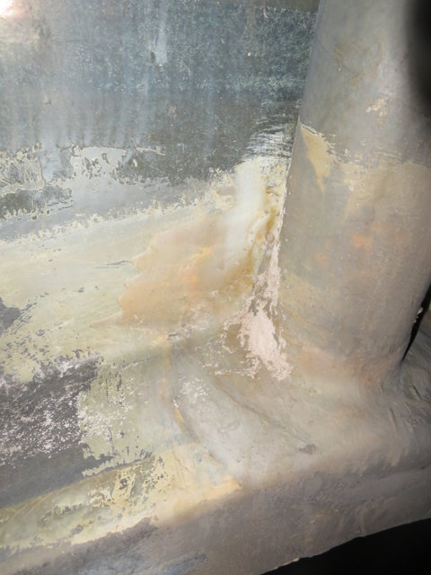
shows | View of Liquid Collection Gutter | 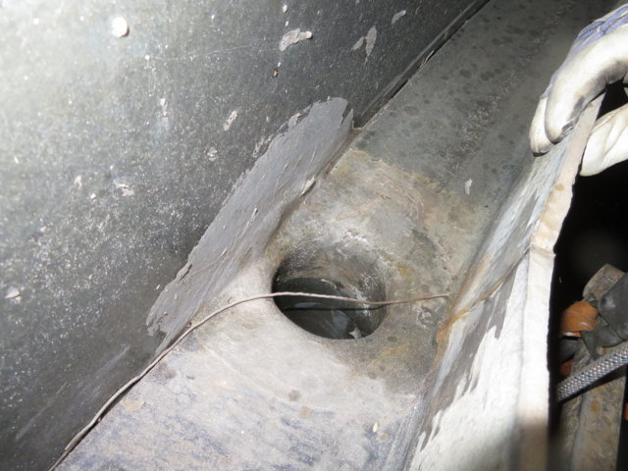
shows | View of Liquid Collection Gutter | 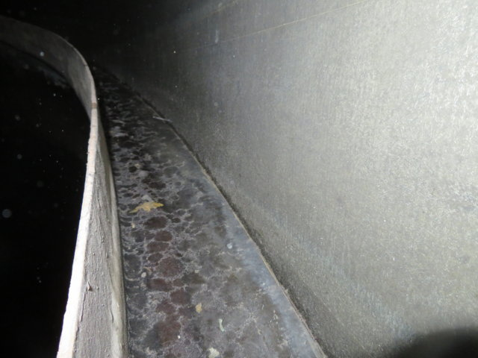
shows | View of Liquid Collection Gutter | 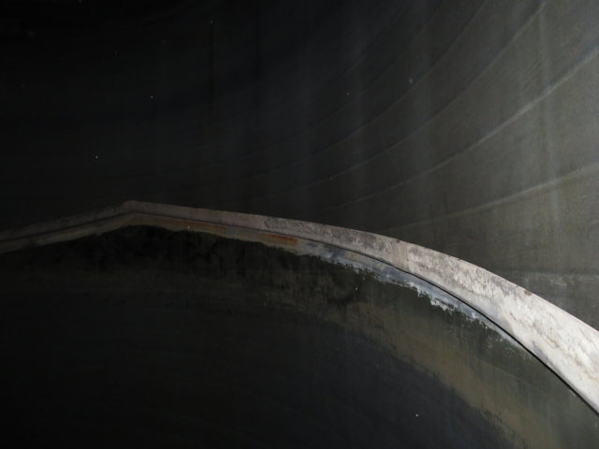
shows | Internal View of Shell at Expansion Joint | 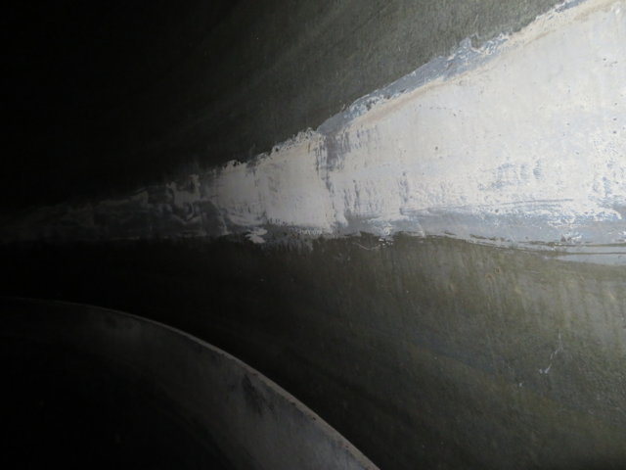
shows | Internal View of Shell at Expansion Joint | 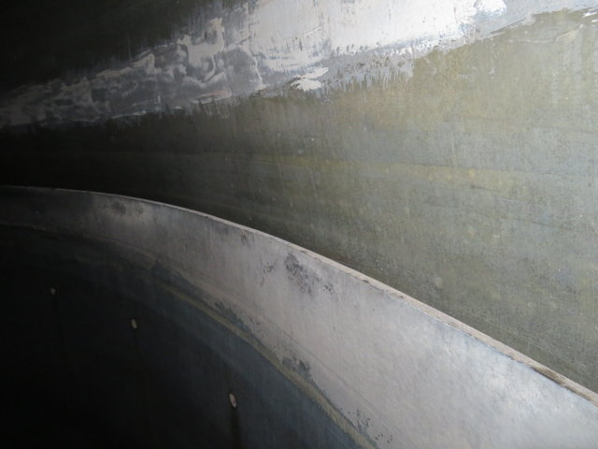
shows | General View of Shell Wall Fracture | 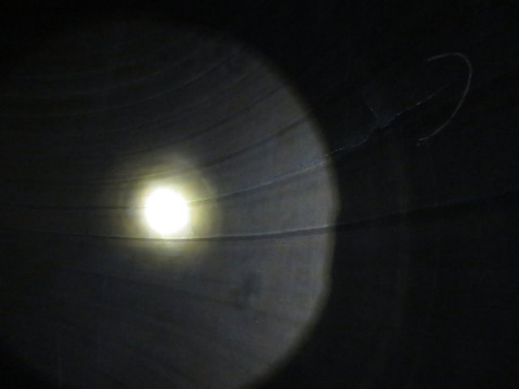
shows | View of Shell Wall Spider Cracking | 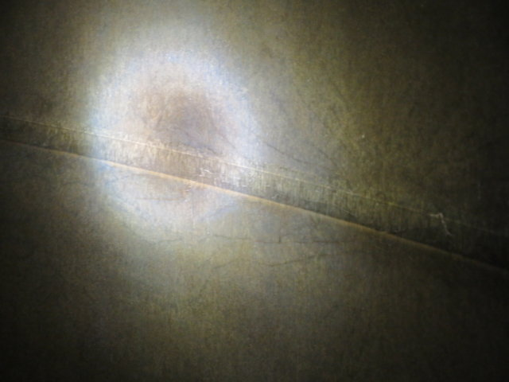
shows | Close-up View of Shell Wall Fracture | 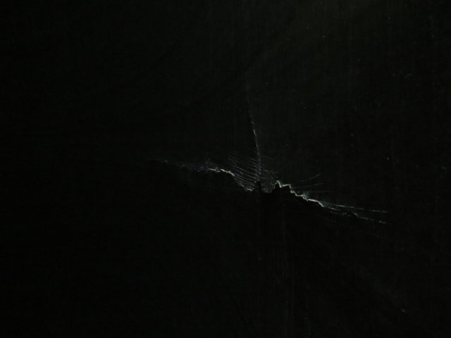
shows | Close-up View of Shell Wall Fracture | 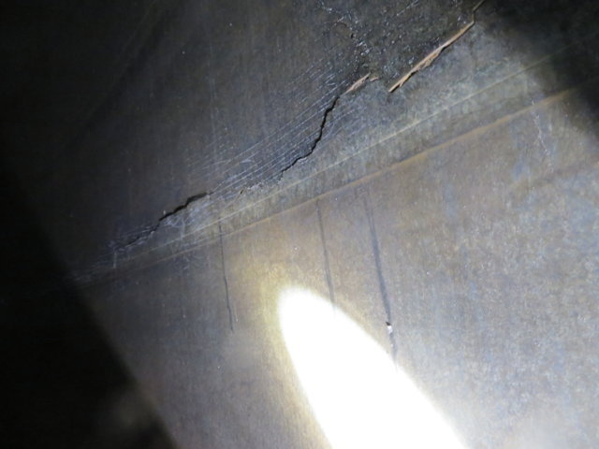
shows | Close-up View of Shell Wall Fracture | 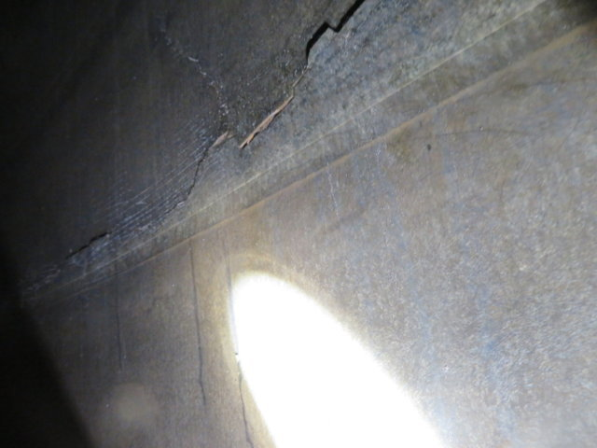
shows | Close-up View of Shell Wall Fracture | 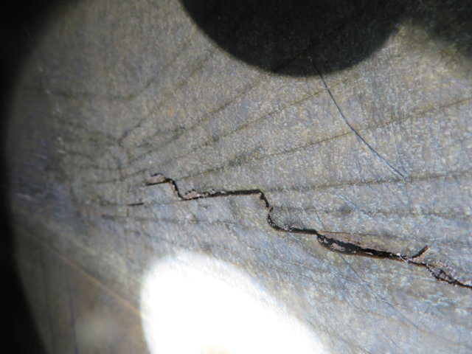
shows | Internal View of Shell Assembly Joint | 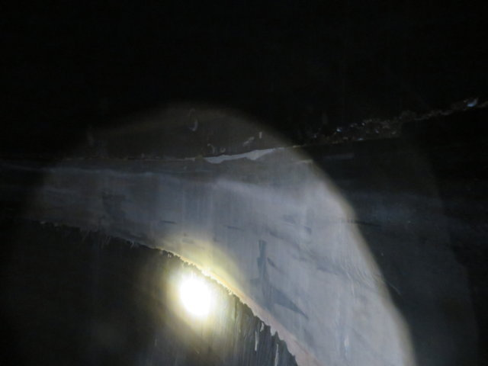
shows | Internal View of Shell Assembly Joint | 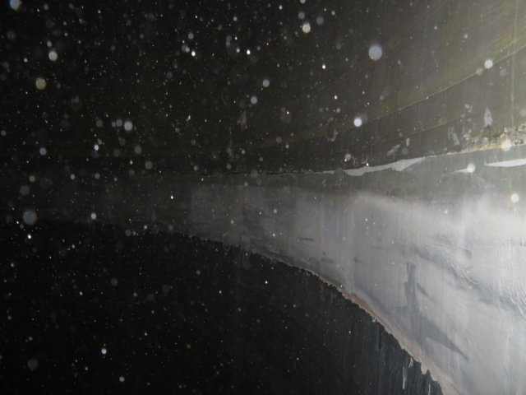
shows | General View of Outlet Duct Wall | 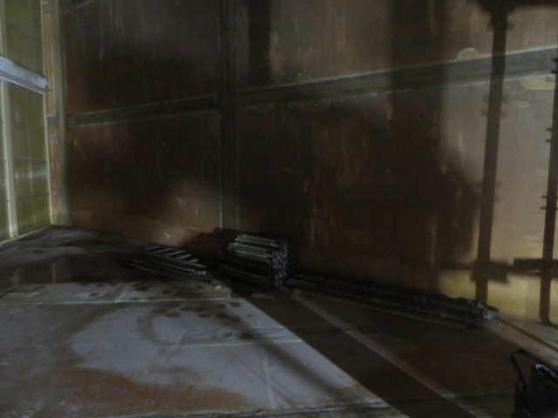
shows | Close-up View of Outlet Duct Floor to Sidewall Overlay Cracking | 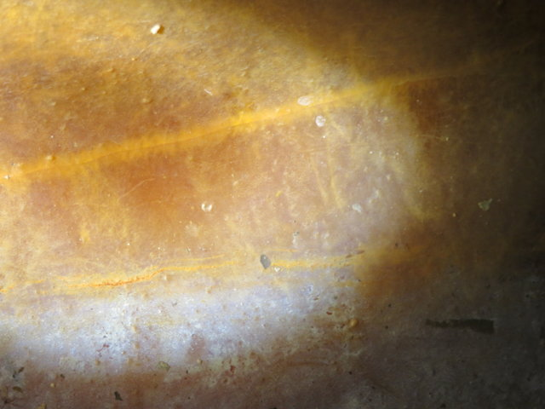
shows | General View of Outlet Duct Wall | 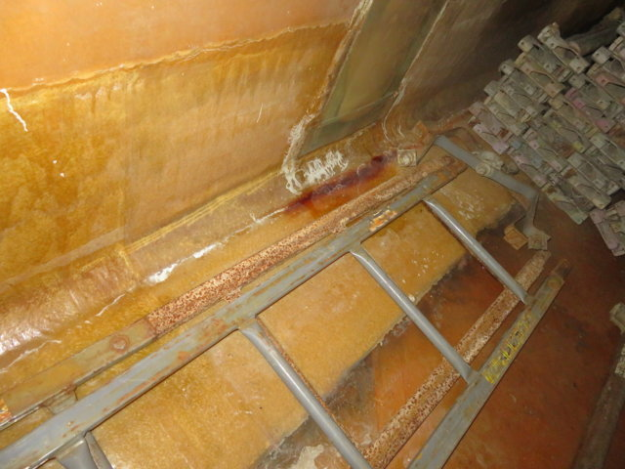
shows | Close-up View of Outlet Duct Floor to Sidewall Overlay Cracking | 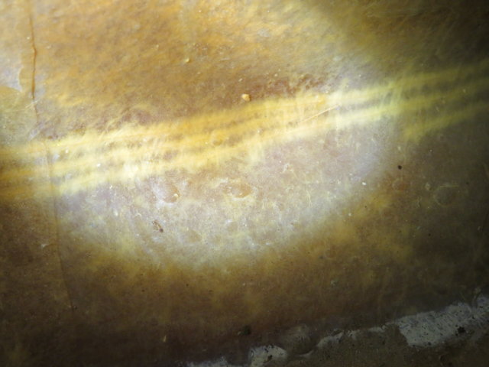
shows | General View of Outlet Duct Wall | 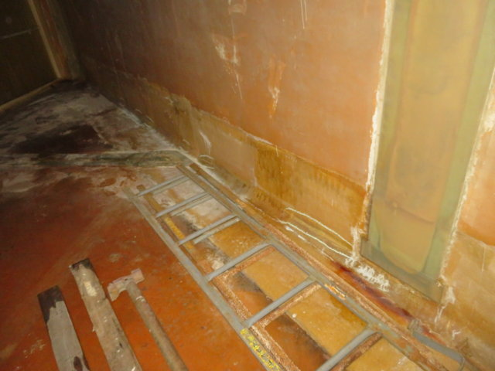
shows | Close-up View of Outlet Duct Floor to Sidewall Overlay Cracking | 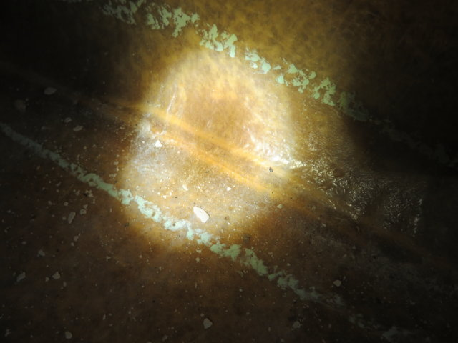
shows | View of Support Displacement | 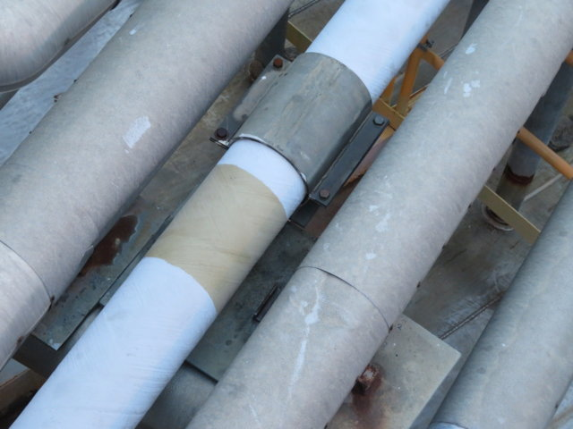
shows | General View of Support Displacement | 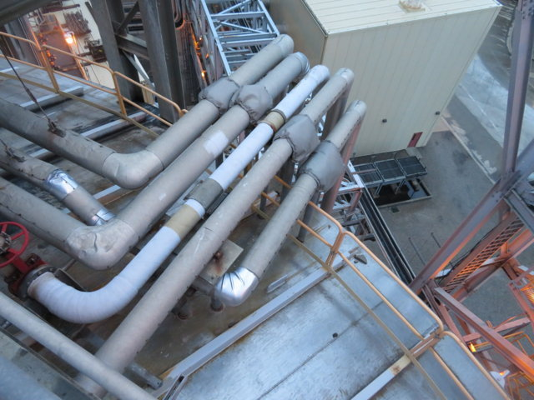
shows | View of Missing Support Location | 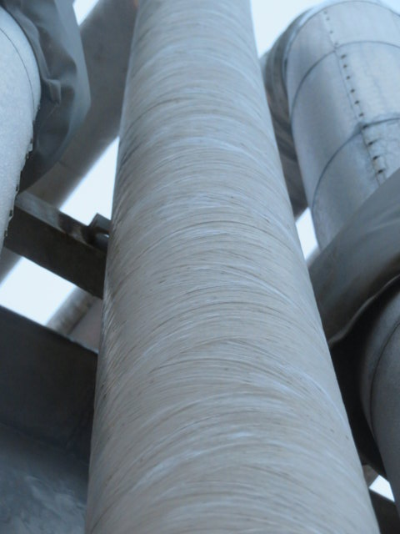
shows | View or Missing Support Location | 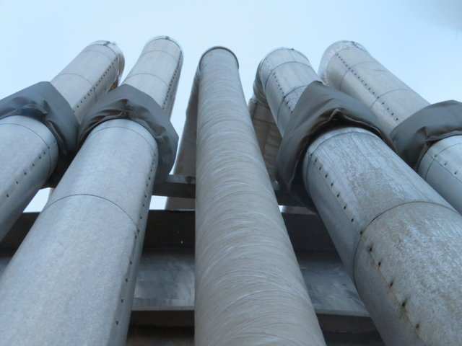
shows | View of Where Upper Support Fell on to Lower Support | 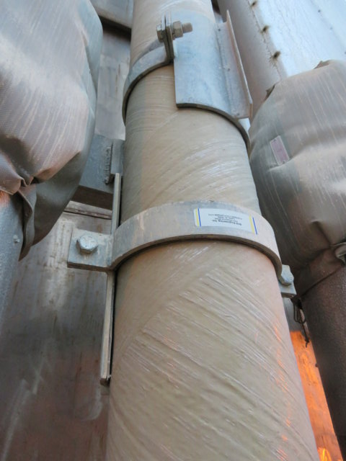
shows | View of Where Upper Support Fell on to Lower Support | 